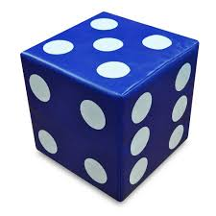
NEA OCR Computer

Science Coursework

CHESS ULTIMA

  - Adrian Odoi

  - 8646

Table of Contents
Table of Contents 2
Analysis 3
Problem Identification 3
Description of the problem. 3
Main aim: 4
How the problem is amenable to a computational approach 4
Stakeholders: 5
General Stakeholders that would be interested in Dice Chess 5
List of stakeholders 6
Interview Questions 6
Research on the problem 8
8
Research on similar solutions 8
Essential features of Solution 9
Limitations of Solution 11
Proposed Solution: 12
Introducing chess: 12
Introduction of the dice (DC): 16
Introduction of probability manipulation (DCX): 17
Interaction with users: 18
Requirements for solution to work 18
Success Criteria 20
Design 21
Breaking down the problem (top-down design): 21
Algorithms: 23
Chess: 23
Tutorial: 24
Die: 24
XDie: 24
Structure of the solution: 25
Usability features: 26
Key data structures: 27
Test data 30
Post-development Survey 36
Development 36
Prototype 1 – Chessboard: 36
Square Class: 36
Board Class part 1: 41
Stakeholder input: 42
Prototype 2 – The working gameplay: 43
Board Class part 2: 43
Piece Class: 47
Pawn Class: 49
Knight Class: 50
Bishop Class: 50
Rook Class: 51
Queen Class: 51
King Class: 52
Finishing off: 53
Testing & improvement: 54
Prototype 3 – Timer: 73
Prototype 4 – Dice: 81
Prototype 5 – Main Menu: 81
Evaluation 83
Post-Development Survey Answers 83
Success Criteria: 84
Usability Features: 85
Maintenance Issues: 86
Conclusion: 86

Analysis

Problem Identification

Description of the problem.
Chess is a very fun and educational game that started its development in 600CE, originating from the Gupta Empire ^{[1]}. Over many centuries it has evolved into the game of chess that many of us know and love today. However, there are two main problems with this game:
- Chess is hard to get into for newcomers, especially today. This is probably due to our fast-paced society, where people can receive a lot of stimulation from social media in a short time, making a strategic game like chess difficult to get into. As social media has developed, people have experienced what is commonly known as “brain rot”, where people’s attention spans deteriorate and the start unironically using vocabulary from social media, which may prevent them from being able to focus on learning such a game.

- On the other side of the spectrum, there are some people who are bored to playing the same chess with the same rules repeatedly. Despite the numerous mental benefits of chess, they may be deterred from playing this fast-paced game.
Both parties are in an unfortunate situation, as playing chess has a wide array of mental health benefits, including (but not limited to) improving memory, elevating creativity and helping to battle ADHD ^{[2]}. For these reasons, it is imperative that I find a solution that will help both parties; a solution that is easy for newcomers to get into, but also complex or engaging enough to keep current players entertained. The solution that I have come up with involves a little bit of luck: Dice Chess (DC)!

Main aim:
The main objectives this project aims to hit is to help people get into chess, which will in turn help more people be able to focus, strategize and plan better.

How the problem is amenable to a computational approach
This problem involves a lot of computational methods including decomposition, algorithmic thinking, abstraction, multiple player systems and random number generation (RNG).

Decomposition:
This problem can easily be broken down into many subproblems.
To finish this game, I’m going to have to create to setup and movement for the board and pieces by integrating graphics into python. I’m then going to have to determine the movement patterns for each piece, including which moves are legal at any point in time or not. I would need to import the random library to allow the dice to be rolled, as well as use graphics to show which numbers the dice have rolled. A file to keep track of win to loss ratios will be required as well. If players decide to play timed games, the time library will be required as well.
There are so many ways to break down each of these subproblems as well, making this easy to decompose.
This is important because trying to solve the whole problem and once and jumping around these roles is an inefficient approach to solving any problem. Decomposition allows me to keep track of how much I’ve done in terms of both the subproblems and the whole problem. It also allows me to test and debug code much easier because I can test these modules separately. It also allows me to easily narrow down where the error may be. For example, if the game allows an illegal move to be played, I automatically know that the error code lies in the movement section and can solve it quickly, rather than having to look through potentially hundreds of lines of code to just to find this one error.

Algorithmic Thinking:
This problem is way too big to solve on its own. To solve it, I will need step-by-step instructions to design and develop a solution. I will also need simple steps to create an algorithm that I can understand and develop further if required.

Abstraction:
There are some elements of chess that I’m going to have to remove from the game to make this problem as manageable, maintainable and efficient to solve as possible. For example, each chess piece has a different height on a real-life board. However, this will be ignored as the pieces will be represented by 2D symbols. When rolling the dice, and animation will be played to show which numbers they land on. To simplify this, I’ll have to ignore the physics of the dice. This means that the number the dice will look like it will land on during animation may be different to the actual numbers.
This is important because trying to add all the little features makes the task more tedious than it should be, making the solution less efficient. It wastes time and memory that I could be spending optimizing or testing my code.

Multiple Player Systems:
Chess is a game played by 2 people, meaning the solution will require a way for more than one person to access the game at once. I will have to implement a system that allows people from different devices a game. However, the same code cannot run for both players simultaneously. One player will need the code run for white and the other for black. Failure to do this will result in both players playing on the same team against nothing, defeating the purpose of the game.

Random Number Generation:
The main premise of this game is to create the game mode Dice Chess. For this to be possible I will have to be able to generate a random number and display it to the user. This random number also must influence the rules of the game by determining what pieces can or cannot move.

Stakeholders:

General Stakeholders that would be interested in Dice Chess
One of the stakeholders is the users of this site: the target audience. The audience will vary in both age and chess experience, so I will need to make a program to cater to all levels of chess mastery. I will require a tutorial for compete beginners who have no idea how chess is played. I will also require difficult bots and an AI to analyse games for more advanced players. For intermediates, I could add lessons and puzzles that will help them improve their skill.
Another stakeholder will be any major companies if I plan to sell this program to them. Their interests will include user satisfaction. This is because they need to keep people using the site to profit from it. They may also be interested in a way to monetise this. I am against making people pay for this site as chess should be accessible to all people of all ages for all financial statuses. However, I am willing to add a premium membership in the future that grants personalised lessons, provided the fee is paid.

List of stakeholders
- The first stakeholder that I have chosen my friend named Henry Olawuni. He is currently doing his A-levels and didn’t get the grades he wanted after his mock exams. I believe that this project will help him develop his memory and concentration, which are crucial for effective revision. He is also not very experienced in chess, meaning he will benefit the most from this project. He will not only improve is cognitive abilities but can immerse himself in a game that will benefit him mentally. It should be noted that he is extremely experienced and skilled in basketball, a physically demanding sport. If he pairs this with the mental strength that chess brings, he could be well rounded overall.

- The second stakeholder I have chosen is another one of my friends called Michael Stringer. He has a lot of experience playing chess, to the point where he has participated in a few tournaments. However, it is difficult for him to find many opponents that could give him exciting and challenging games. This project will help to build players up to his level, so that they may perhaps bring him the fun that chess used to bring. He may also benefit from the benefit of the dice variant, as essentially a new and refreshing game which requires more than just strategy.

- The final stakeholder I have chosen is another Year 12 student called Efe Tobore. She is currently doing 3 A levels but is really struggling in them. She has been playing chess for about a while and is knowledgeable in it but struggles with blundering and making mistakes in the game. This program would be perfect for her, as she’ll be able to improve at her level without having to start from the basics.

Interview Questions

- How long have you been playing chess for?
- 7 days
- 8 years
- Just over a year ago

- On a scale from 1 to 10 how would you rate your skill in chess?
- 1-3
- 7-8 (1500-1700 rapid rating on Chess.com)
- I would say 5 because I'm lower intermediate (~950 in Chess.com)

- Use 3 words to describe chess.
- Thought-invoking, strategic, mentally testing
- Strategical, Fun, Self-Improving
- Analytical, enjoyable, challenging

- On a scale from 1 to 10 how would you rate your ability to concentrate and focus on tasks?
- 5 – Can focus if the need arises
- 4 – Get distracted easily
- 7 - it really depends on where I'm doing said task but for the most part, I'm good at focusing

- Are you aware of the mental health benefits of playing chess?
- Yes, it trains your memory retention and allows you to improve your ability to recall useful facts.
- Yes, it allows you to approach tasks/problems differently.
- Yes, I am but I can't list any studies or statistics by heart

- Do you believe that playing chess can help you focus, analyse and plan better in your studies?
- Yes, I do believe so.
- Yes, although I can’t say I have been utilising it.
- Yes. I believe it improves your ability to focus for long periods of time, plan your time and improve your answers in exams

- How do you think playing chess can benefit your everyday life?
- I guess it could help you strategize your moves in other activities, like basketball
- Improves mental strength while being enjoyable
- It can improve memory, strengthen social bonds and generally be a fun game to play

- What do you think of adding dice to chess?
- I don’t really mind but I want to focus in regular chess
- I like the idea of a spin on the game, it would allow the opponent to never truly know what you can achieve in one turn, leaving both players on edge.
- I think it would be a cool addition to the game that would make it more interesting especially since chess is such an old game and new rules are rarely added

- What are some features you require from this program to make it as useful to you as possible?
- A reminder/prompt about castling so any time I attempt to move my king without a viable or obvious reason I will be reminded about the castling technique
- Possibly being able to adjust probabilities, possibly increase chances throughout the game, or have buffs such as sacrificing a piece or pawn for better odds during the game (speculative)
- Game reviews; pre moving; the ability to set up custom games (where you place any piece in any order). Maybe a few different game modes (e.g. 4 people chess, round chess, chess on 5 boards etc).

Research on the problem
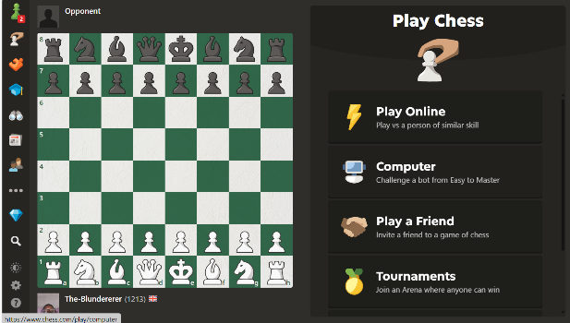

Research on similar solutions
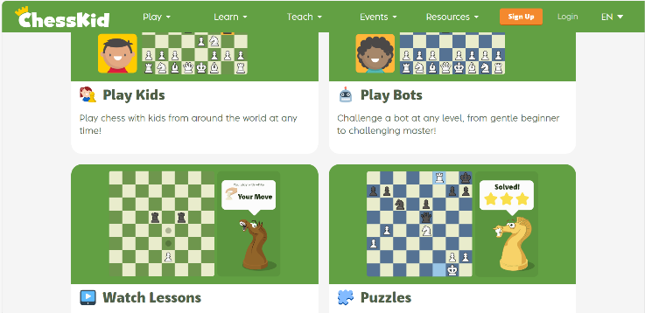
There are many existing solutions to similar problems, such as Chess.com ^{[3]}, where players can practice playing chess with puzzles as well as play games with people online from around the world.
Another solution is Chesskid.com ^{[4]}, a version of Chess.com designed specifically for children. It includes kid-friendly designs for pieces and a more appealing design.
My solution is that it is aimed at teenagers and adults who want to learn chess. They likely wouldn’t approve of the immature design of Chesskid.com but may find learning from Chess.com more complicated. This is the reason why I think it's important for me to add a mandatory tutorial before playing the first game of chess. As normal chess is complicated, a certain win/loss ratio will need to be maintained to play dice chess, with a tutorial for the first dice chess game against an easy AI bot.
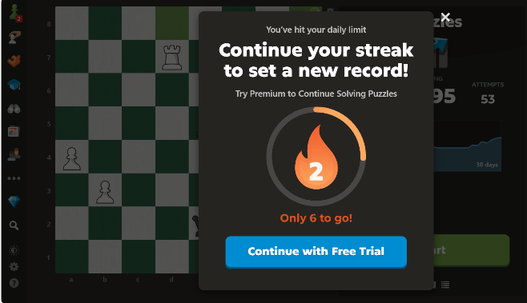
An additional problem with Chess.com is that, whilst it is free, you do have to pay a premium price for additional features. On the free version you are limited with the number of puzzles, lessons and game reviews you can try per day. My solution aims to make this free. It will work by keeping a log of the moves, then using AI and potentially Stockfish to generate an analysis of the game free of charge. As for the puzzles and lessons, I can use links to lichess.org and YouTube videos.
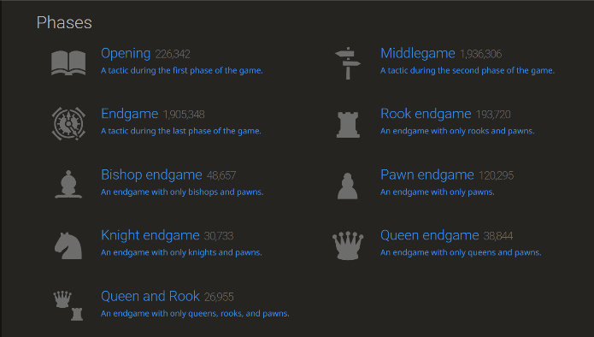
Speaking of Lichess^{[5]}, it is a good source of puzzles on a wide range of situations from openings to checkmates. Puzzles can be played an unlimited number of times for free, as it’s a non-profit organisation. It also separates them into themes / phases, making it easier to navigate the puzzles and focus on your weaknesses. The screenshot on the right is not an exhaustive list of the themes of the puzzles.

One thing that Chess.com does well is allow you to set whether you’re a beginner, intermediate or advanced player, which automatically set opponents on a similar level for you to play against. I will take inspiration from this and use this in my own program, perhaps by recommending puzzles to test a player at a given level.
It also stores the moves for any given game as well as the game itself. It also allows access to Stockfish, a chess engine that analyses your games and gives you feedback. This allows for game reviews and self-reflection which can help players improve
DC is also aimed at those who want to play a different version of chess. Chess.com does have some solutions for this, including 4 player chess, spell chess and atomic chess. This is just another one of those twists that could be implemented. Additionally, Chess.com does not have a dice variant at the time of writing this.

Essential features of Solution

Nº | Feature | Justification
1 | Permanent files | - Provides users with their statistics for the week, month, year and all-time.  - Allows users to track their progress and set goals for themselves to improve.  - Enables users to adjust strategies that haven't worked for them historically.  - Permanent files are also useful for storing previous games to be later analysed or to see how much progress the user has made in chess
2* | Legal moves | - Users must only be able to make legal moves to uphold the rules and integrity of both Chess and DC  - Users can recognize the rules of which moves are illegal.  - Without this, the users will be spending a lot of game time trying to figure out what move is illegal, rather than applying chess tactics and strategy
3* | ONLY 2 Player | - Chess is a 2-player game and Dice Chess is not a variation that allows otherwise  - The lack of 2 player feature breaks the rules of both games, making this program ineffective
4 | Chess Engine | - Chess engines like Stockfish or Leela will be essential to helping players analyse games as nobody has the time to write analysis for every possible move (there are over 5000 distinct chess positions after only 3 moves, not including the many ways to get to said positions).  - Chess engines can perform analysis much quicker than humans and significantly more accurately than the players themselves. However, there is room for error with all chess bots. Additionally, the engine analyses the game assuming that you are playing against an engine that makes the top moves.  - Stockfish will likely be used as it is an open-source engine that Chess.com commonly uses
5* | Storage of moves in a game | - Sets up a quick table of moves for white and black including the letter of the piece moved (not included for pawns as that is standard chess notation) and the coordinates of the square it moved to. For example: Nc6, e4, Bb7. Other types of chess notation include…  - O-O means kingside / short castle.  - O-O-O means queenside / long castle.  - An ‘x’ between the piece letter and the square’s letter coordinate suggests a piece was captured. [Nxb6]  - A ‘+’ after the square’s number coordinate suggests the move resulted in a check [Qh5+]  - A ‘=’ after the square’s number coordinate of a pawn move suggests that the pawn has promoted. A letter (either Q, B, N or, R) should be placed after to show what piece the pawn promoted to. [e8=Q]  - A ‘#’ after the square’s number coordinate suggests that move resulted in a checkmate, ending the game. [Ra1#]  - Storing the moves in this format makes it easier to store moves to either be referred back to or for stockfish to analyse
6* | Random selection of numbers from 1 to 6 | - The random selection is objectively essential to the success of Dice Chess, as it will be used for the dice itself.  - The random selection allows the element of randomness to be added to chess which is part of the solution.
7 | Confirming if the player wants to make a move that prevents castling | - One of my stakeholders, Henry, usually moves his king when he’s in check and whilst that’s not necessarily wrong, it’s bad gameplay in the beginning as he loses castling rights and misses an opportunity of developing a piece  - For him, I plan to make an alert every time a player wants to move their king or rook for the first time  - If the player moves their king for the first time before either or both rooks, there won’t be notifications for moving rooks for the first time  - If the player moves both rooks before their king, there won’t be notifications for moving the king for the first time  - This feature cannot be force for every game for 2 main reasons:  - Not all players will require this feature, so it would simply be unnecessary  - Time is more valuable during shorter games, so this feature may inconvenience players  - The best solution would be to simply allow players to toggle this feature on and off as they see fit, but it will be forced to be off for games under 3 minutes per side
8 | Adjust probabilities
9* | Access to chess engine and notes | - My final stakeholder, Efe, has requested that I add game review to the application, however I cannot provide one like the one on Chess.com due to the scope of this coursework  - A solution to this would be to allow the player access to the engine’s notes for each game, as well as a blank digital notepad for them to annotate in  - This would allow player to see where they went wrong and make improvements in their tactics and board vision  - I would also allow the player to see areas in which they are weak and improve on those rather than just guessing
10* | Time increment | - This feature simply allows the player to automatically increase the time by a set amount for a player for every move they make  - This feature allows games to go on for longer and adds an element of swiftness to the game as players are explicitly rewarded for fast moves  - An example of when increment is useful is when a player can checkmate their opponent but doesn’t have enough time to. They can solve this problem by making random moves to build up time to think about checkmating.
11 | Pre-moves | - This feature was also recommended by Efe  - Pre-moves allow player to make a move on their opponent’s turn, but it will be played instantaneously after their opponent moves as to not disturb them.  - Pre-moves are stackable  - They allow players to save time during a game as they can just focus on the next move and don’t have to worry about spending time moving the pieces  - This feature is crucial for bullet and blitz games where time may have a slight priority over chess skill  - With the increment, it makes it easier for players to build time to think

Limitations of Solution
- Adding game modes won’t be possible to this project
  - Due to time constraints, adding additional game modes will be outside the scope of this project
  - Adding too many variations may take up a lot of memory, causing the main games to run slower or less efficiently
  - It may be difficult to manage multiple different modes at once that are not that much related
- I am unable to create a lot of puzzles or lessons, nor can I separate them into a wide array of themes. This is because there are so many ways to play chess that I cannot make that many puzzles myself Chess.com alone has about half a billion puzzles. I also cannot steal them because of copyright issues. The best I can do is send links to lessons on YouTube and puzzles on Lichess.com. I might also be able to separate puzzles into a few themes, such as checkmates, openings and endgame tactics, but most of them will have to come under a miscellaneous / other section.
- I cannot add chess with 3D pieces as it would take too much time to develop and take up too much memory, potentially slowing down the main games. This will limit its effectiveness because chess is usually played on the board with 3 pieces. This limitation may limit the practice with board vision on the actual board. However, many chess sites do not have this feature and many people, including myself, have reported an improvement with real life chess from 2D chess.
- Stockfish, the best chess engine, is a bit flawed. This is because it makes analysis based on Stockfish vs Stockfish games with no time limit rather than human games with time controls. This may have players feel like they are not making progress, even though they are, as they take time into account with their moves. Another problem with stockfish is that it takes time to produce good analysis. It might take over a minute of processing to provide the best moves, which may take away from the speed of the other parts of the program.

Proposed Solution:

Introducing chess:

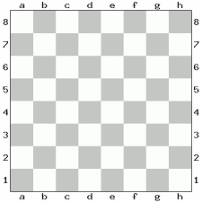
Game setup (Board):
The setup of the game will remain unchanged from to original game to maintain its integrity and prestige.
Chess takes place of an 8 by 8 rectangular grid, with ranks (rows) sorted from 1-8 and files (columns) sorted from a-h. Each tile has a code that consists of a letter from a to h and a number from 1 to 8 to tell us its file and its rank. For example, e4; g6; b8. It consists of only black and white tiles that alternate, starting with a black tile on a1. Its setup happens to be in such a way that horizontally and vertically adjacent tiles have opposite colours and diagonally adjacent tiles have the same colour.
Depending on the colour scheme, the black tiles may be swapped for another colour like green or brown and white tiles swapped for lighter variations of the ‘black’ ones to improve the appearance of the board which may also apply for the pieces. However, it should be clear what tiles represent “black ones” and “white ones”. Examples of different colour schemes may be seen on the next sections.

Introducing the pieces:
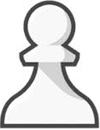
The movement patterns of each piece will remain unchanged from to original game to maintain its integrity and prestige.

Pawn (Corresponds to 1 on the dice):
The pawn is the most common and most iconic chess piece, being the Chess.com logo. Its movement pattern is both simple and complex. It has a piece value of +1.
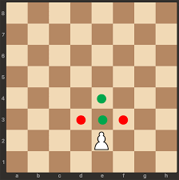
It can only move one space in front of it (in the direction of the player using the pawn). However, it may move 2 squares forward only on that pawn’s first move, known as a pawn boost.
It attacks pieces on the adjacent diagonals in front of it, but not the diagonal behind it. The pawn can never attack or move backwards, meaning it’s the only piece that cannot move back to a previous position. That means that when a pawn captures an enemy piece, it must land on the same square and stay there until the next turn. This rule goes for all pieces. It cannot capture pieces of the same colour.
When the pawn moves the rank on the other side of the board (8th rank for white or 1st rank for black), it must promote to a bishop, knight, rook or queen, but not a king.
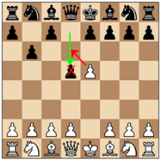
Pawns have one more special move called ‘En passeant’, originating for the French translation of ‘In passing’. When an enemy pawn boosts and lands horizontally adjacent to the player’s pawn, the player can still capture the enemy pawn in the same way as a normal capture, landing behind the enemy pawn. However, this can only be done directly after the enemy pawn boosts. Waiting to en passeant is not legal.
Knight, N for short (Corresponds to 2 on the dice):
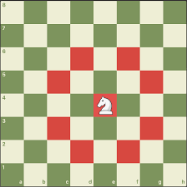The knight (also known as the horse) is another piece that helps guard the king and the only piece that can jump over other pieces, meaning it is the only piece other than the pawn that can make the first move. Its piece value is +3.
The knight can move in an ‘L-shape’, meaning that it can move 1 or 2 spaces either vertically or horizontally then 2 or 1 spaces in a perpendicular direction. For example, it can move 2 spaces forward or backward then 1 square left or right, or 2 spaces to the left or right and 1 space forward or backward.
Should there be an enemy piece on the square the knight lands on, that piece will be captured. The knight cannot land on a square where a piece of the same colour is, because that will involve capturing that piece. Knights cannot capture pieces of the same colour.


Bishop, B for short (Corresponds to 3 on the dice):
The bishop is a piece that helps guard the king and is one of the first pieces to be developed in a typical chess game, with a piece value of +3.
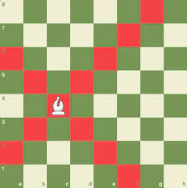
The bishop can only move in a diagonal motion any number of spaces if it is not blocked by another piece or the edge of the board. Since we discussed that diagonal tiles have the same colour, a bishop that starts on a black square will never land on a white tile and vice versa, regardless of the bishop’s colour. It is unable to jump over pieces, whether allies or enemies.
The bishop attacks the first enemy piece that block its path of attack on its diagonal path. It cannot capture pieces of the same colour.
Bishops and knights are both considered the “minor pieces”.


Rook, R for short (Corresponds to 4 on the dice):
The rook (also known as the castle) is another piece that guards the king and one of the most powerful pieces on the board. It has a special move with the king called ‘castling’, which will be discussed in the king’s introduction. Its piece value is +5.
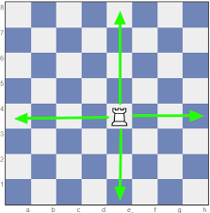
The rook can move horizontally or vertically and number of spaces in any direction provided it is not blocked by another piece or the edge of the board. It cannot change its direction in the middle of the move, meaning that it lands on the same file or same rank it was on before the move (it can change the in another move).
The rook attacks the first enemy piece that blocks its path of attack on its rank or file and lands on its square. The rook cannot capture pieces of its own colour.


Queen, Q for short (corresponds to 5 on the dice):
The queen is the most powerful piece on the board and stands right next to the king. It combines the benefits of a rook and a bishop and puts them into one piece. It is the most valuable piece with a piece value of +9.
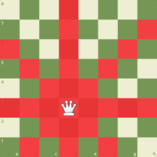
The queen can move horizontally or vertically any number of spaces in any direction provided it is not blocked by another piece or the edge of the board, like the rook. It can also move any number of spaces in any of the diagonals like the bishop. It cannot do both in the same move. To put it simply, it can move either as a rook or a bishop on its turn.
The attack pattern of the queen is the same as the bishop and rook, capturing the first enemy piece in its way and landing on its square, stopping its movement for that turn.
Queens and rooks are considered “major pieces”.

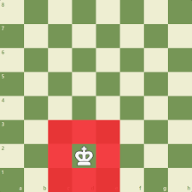
King, K for short (corresponds to 6 on the dice):
The king is the main piece in the game, that needs to be always protected. It is the only piece that technically cannot be captured. Instead, the player’s king is in “check” when under attack and the player’s next move must get the king out of check to continue the game. Failure to do is illegal and will not be processed as a move.
If there is a situation where any possible move would result in the king being captured and the king is in check, that player loses the game, known as “checkmate”. “Stalemate” is when a player’s king is not in check but there are no legal moves (as it would be put in check). This results in a draw for both players.
Due to its inability to be captured, it does not have a defined piece value associated with it. There have been some arguments about if the value of the king should be zero or infinity.
The king can move 1 square horizontally, vertically or diagonally provided that the square is not occupied by a piece of the same colour and moving the king to that square does not result in a check.
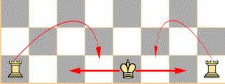
The way that castling works is by moving the king two spaces to the left or to the right, then moving the rook on the opposite side right next to the king. This move is only legal under a few conditions:
- The king has not moved (even if in the same position)
- The rook you want to castle with has not moved (even if in the same position)
- There are no pieces, between the king and rook you want to castle with, regardless of colour
- The king is not in check
- The king doesn’t move onto or over a square that’s being attacked
The king attacks in the same way it moves; if an enemy piece is vertically, horizontally or diagonally adjacent to it, the king may capture that piece if it is no guarded by another enemy piece, because that would put the king in check.
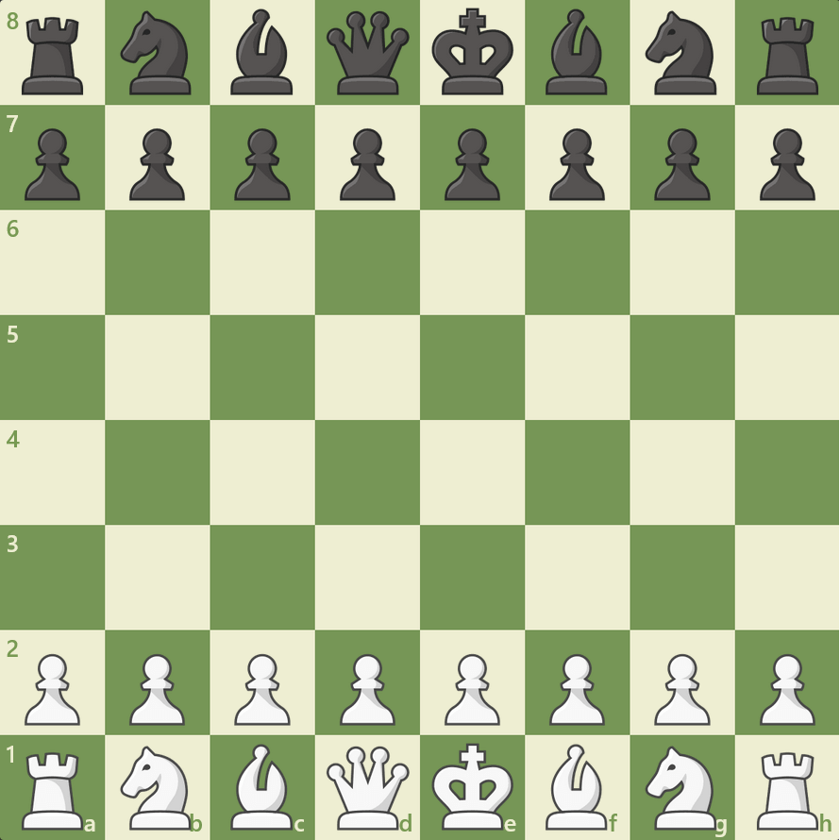
Game setup (Pieces):
In chess, there are 32 pieces on the board to start (16 a side):
- 8 pawns a side
- 2 bishops a side
- 2 knights a side
- 2 rooks a side
- 1 queen a side
- 1 king a side
For white, all the pawns are set up on the second rank. The higher value pieces are placed on the first rank, with the rooks on the outer files (a and h files), 1 knight next to each rook (b and g files) and 1 bishop next to each knight (c and f files). The queen is always place on the d file and the king on the e file. This setup the same for black, except the pawns are placed on the 7th rank rather than the 2nd and the bigger pieces on the 8th rank rather than the 1st.
To help new players, I would tell them to place the big pieces at the back and starting from the outside in, place rooks then knights then bishops. Then place the queen on its colour and the king on the final square for that row. Then place all the pawns in front and mirror for black.

Introduction of the dice (DC):
Dice Chess is very similar to regular chess, with the same board, movement patterns and rules. However, there is one twist, 2 6-sided dice will be rolled with the number rolled corresponding to the piece that can be moved:
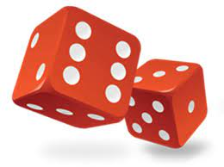
1 – Pawn
2 – Knight
3 – Bishop
4 – Rook
5 – Queen
6 – King
The original idea involved only having one die being rolled, but after asking Michael, I decided to have 2 dice to allow one of two pieces to be moved in a turn (but not both pieces in one turn). Should the same number be rolled on both dice, the player will be able to move the corresponding piece twice in the same turn. Should there be no legal moves with the piece corresponding to the number rolled, the player is able to make any legal move, regardless of the number rolled. Should a piece of that type not be on the board, the player’s move is skipped.
The dice element is the twist that I have decided for this variant of chess. Regular chess is a game of pure strategy. Losing in chess means you made at least 1 mistake that your opponent took advantage of, regardless of how small it is. The beauty of chess is that you can look back at your games and see where you went wrong to improve. This helps player learn self-accountability.
However, newcomers may not really care about looking back or have the patience to. These players should still be able to enjoy this game without the pressure of having to constantly adapt to new openings, strategies, tactics, etc. This is where the dice come in.
By adding an element of randomness to the game, it may take away the pressure of losing in chess as wins and losses are based on more than their chess skill. This adds a refreshing aura to the game and allows new players to have an experience that is like Uno or Poker.
As for experienced players, it may help them improve their strategy as they will have to try to win even when the odds are against them (regardless of whether they slipped up or not). This may help those players improve their chess skill.

Introduction of probability manipulation (DCX):
Dice Chess Xtreme is a more extreme and complicated version of Dice Chess. It manipulates the probabilities based on how player play the game. This game mode was recommended by my stakeholder Michael will be implemented into this project. The new dice will be called the XDie.
The rules below are added on top of the rules for Dice Chess.

Rules:
- Probabilities won’t change until a piece enters its opponent’s half of the board (until a white piece enter ranks 5-8 or a black piece enters ranks 1-4). This rule overrides all other rules.
- If a player captures an enemy piece, the probability of a rook or queen being rolled is 20% less likely than other pieces for that move (not stackable)
- If a player promotes a pawn, the probability of a 1 being rolled reduces by 25% for that move
- If a player is in check, the probability of rolling 6 increases by 50% for that turn
- All probabilities must add up to 1 and it is impossible to adjust just 1 probability without affecting the rest. For this reason, I will add a F4L roll, portrayed with the number 7, which allows a player to move any piece on their turn. This means that the dice is now 7-sided with a 1 in 7 chance of each number being rolled until the first rule is broken

Interaction with users:
The program is supposed to help people learn chess, but the primary reason for it is to help people experience mental health benefits, as well as improving concentration and memory. This is the reason that after every game a player will have 5 choices:
- Request a rematch from the same opponent
- Start an entirely new game with the same time controls (or lack thereof)
- Look back over the game and analyse any mistakes misses or blunders
- Access to resources to improve mental strength
- Go back to the main menu
There will also be a tutorial accessible and easy to find for new players to help them learn how to actually play. The tutorial will not only include the movement of all the pieces, but also a few common openings, such as the Knight’s Opening, the Queen’s Gambit and the Caro-Kann. It will also include some common tactics, like pins, forks and skewers.
Playing Dice Chess will require a certain number of wins and a win/loss ratio to be attained. The ratio does not need to be maintained to continue playing dice chess, otherwise it may put pressure on players or scare them from playing Normal Chess to avoid losing that ratio. There will also be a required tutorial to play Dice Chess, which will be an extension of the Normal Chess tutorial. It will introduce the dice and how they work, as well as more complex tactics, such as centre control and tactical defence.

Requirements for solution to work

Hardware Requirements (On the user’s end)
- The user will require one of the following:
  - Device with a touchscreen, including phones, iPad and tablets: A mobile touchscreen will allow to tap the piece you want to move, then tap the square you want to move it to. Alternatively, you can drag the piece from its current square to your desired square.
  - Mouse: Similarly to the touchscreen, you can either tap the square of the piece, then the square you want to move it to or drag the piece to its desired square
  - Keyboard: The player should be able to type in the move they want to make using the standard chess notation. This will allow players to make moves without a mouse.
- The user will require a screen that can present the chessboard and the pieces. This is because it is hard to visualise the pieces without the board, let alone look multiple moves ahead. A screen that can show the game is indisputably essential to the solution to work.
- The user will also require a GPU to display the graphics of the chessboard and pieces
- The user will require a working processor that can run the solution fast enough to play it live and run python. 1.5GHz or better is recommended.
- The user will require an internet connection from a router, ethernet cable, mobile data or hotspot to play live games with other people. These games will be played in real-time, making this required to being able to use the application.

Software Requirements (On the user’s end)
A software requirement is a real-time operating system. This is because most games players are likely to play are online and it will be hard to win if your game is lagging. The moves will be made live in real-time, so an OS that allows such is necessary. The software also needs to be compatible with python since that is the programming language the game is being run on.

General Requirements (On my end)
Nº | Requirement | Justification
1 | Player must be able to play with only one other player online | The 2-player nature will uphold the tradition and rules of chess without overcomplicating it. There are variations that allow for more players, but this does not include those, making them not only redundant, but also more complex for the user to play. They must be able to play online as it may be difficult to find players in real life from the comfort of your own home. This requirement aids with convenience.
2 | Players must not be able to make illegal moves | Illegal moves not only make the game unfair, but it also takes away the benefits of playing chess from the cheater, such as pattern recognition and concentration. Illegal moves also defeat the entire purpose of the game, as the unpredictability makes every tactic, strategy and skill in chess useless, regardless of experience.
3 | Game end after a clear win, draw or loss | The game must end and prevent players from making further moves after a someone wins, loses or draws. This would prevent players from being stuck in the game indefinitely. It should also give the reason for the win / loss / draw. For example, if white stalemates black or vice versa, the game should output “Draw by stalemate”.
4 | Chess Engine | Humans are not perfect at playing chess and usually make mistakes when analysing positions. Chess engines like Stockfish analyse positions with a higher degree of accuracy, allowing players to see where they went wrong and adjust accordingly.
5 | Each player must have their own account | Players will need to be able to access their stored games and progress, while not being able to access others’. This will ensure privacy for each player and permanent storage. As a result, allowing players to have separate accounts will prove useful in privacy and storage of data.
6 | The player must be able to access all other areas easily via the main menu | The main menu allows the user to access all other areas of the program, including the games, setting, help and stored games. This is essential to navigation and ease of use.
7 | The board and pieces must be the right shape, size, arrangement and colour | - The squares of the board should all be the same size and have an alternating colour pattern horizontally and vertically with the same colour diagonally to mimic that of a regular chessboard. The specific colours may change depending on what the user finds comfortable, but the white and black squares should be clear as they will be a lighter shade and darker shade respectively.  - The pieces must be able to fit in the squares and be the right colour on the right side of the board. They likely won’t be the exact same colour as the squares, but if they are they will have a clear bold outline. They should be shaped in a way such that it is clear which piece is which. For example, knight should somewhat resemble a horse, rooks should somewhat resemble a castle, etc.
7 | The games must have a simple gameplay | - Each game must be easy to understand in terms of making moves. This reduces the likelihood of player quitting due to being unable to figure out how to play the game  - This requirement only considers using the algorithm, rather than how to win or improve at the games.

Success Criteria
- Main menu
  - The main menu will be the place where players can access each game mode: “Chess”, “Dice chess” or “Dice Chess”
  - The menu will also contain a tutorial for new players which will include rule, basic and special moves and a few pieces of key terminology
  - Learning chess definitions will be useful because players are more likely to use them in the actual game. For example, you are more likely to pin a piece if you know what a pin is
  - The menu will also have access to settings where you can toggle features that you want or don’t want
  - The main menu will basically branch out to all other areas and features of the application
- Give players the option between playing Chess, DC or DCX
  - Not all players would be interested in playing chess variations so it wouldn’t be fair to force it onto them
  - Conversely some players would be bored of chess and would want to play the variations a lot
  - Some players would want to switch between these variations, and I should give them the option to at any time
- Create a visual model of the chess board and chess pieces that users and interact with
  - It is impossible to play digital chess accurately without seeing the board and pieces, so each player requires visual access to the actual chessboard
  - The players will also need to be able to interact with the pieces in order to move them along the board
- Determine what moves are legal and what moves are not
  - Legality in chess is what stop the entire game from being too chaotic to think.
  - Some players may not know what moves are illegal or why their attempted move is illegal, so it might be useful to have indicators to show what moves are legal when they select a piece.
  - If a player attempts a legal move, the reason will appear on the side of the game for 5 seconds to give them time to read and understand.
  - There are multiple reasons move could be illegal:
    - The move is out of the scope of the piece’s movement pattern
    - The move will put or keep their king in check
    - The player has lost castling rights
    - The square is occupied by a piece of the same colour
- Allow for all kinds of moves
  - Allowing for both basic and special moves (en passeant and castling) will allow players to play their best chess fairly
- Include a chess timer
  - A chess timer is an essential piece of most chess games as it keeps a player from stalling and applies pressure on both players
  - A chess game would not be complete with a time as most chess tournaments include it
  - I could also allow a mode where players have a whole day to make a move in case they don’t want to be under time pressure
- Keep track of the moves made in real-time and store them
  - Keeping track of moves allow players to refer back to them and see anything they might have missed during the game
  - It also allows players to go back over their games and analyse them
- Use random number generation
  - Random number generation is a key component of Dice Chess and Dice Chess Xtreme to stimulate the roll of a dice
  - For DCX I could use NumPy to influence probabilities based on the moves played
- Have the program be easy to navigate
  - In order to use the application, it is essential that users can easily find their way to the section that they want to find
  - Without this, trying to boot up a game might be more difficult than actually playing it
  - Difficult navigation might turn people away from Dice Chess, as they may get frustrated

Design

Breaking down the problem (top-down design):

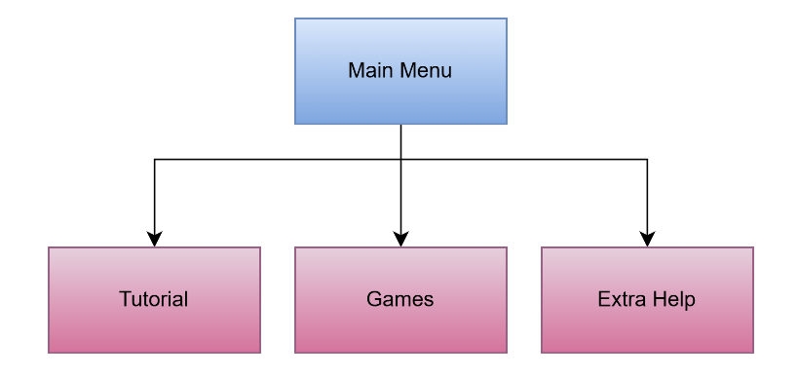
This diagram breaks down the problem from the main menu into 3 different parts: Games, Tutorial and Extra Help.
The Games section allows the user to play either Chess, Dice Chess or Dice Chess Xtreme. This is required so that the user can play the. games and experience the entertainment and benefits from these chess variants
The Tutorial section gives the user a tutorial on how to play the game. This is required as some people do not understand how to play chess at all and need help to start
The Extra Help section provides resources on how to improve at chess or mental strength. This is necessary to achieve the goals of the project, as these resources will allow players to improve their chess game and mental health. It will also provide more awareness between the link between chess and focus.
The main menu is necessary for this because it allows users to easily navigate the program and use it to the best of their capabilities. It helps achieve parts 1 and 9 of the success criteria.

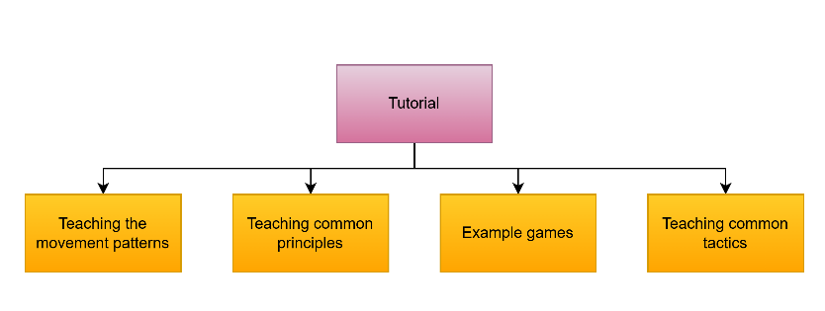
The tutorial is the mechanism that teaches the user how to play chess, but not the variants. It has 4 components:
Teaching movement patterns: The player needs to understand how the pieces move to avoid making random moves. It will also help them understand what an illegal move is how to use the ideas in the rest of the tutorial.
Teaching common principles: The player needs to understand principles to play good chess, like taking the centre, trading pieces, pawn structure, etc. Due to time constraints this section will not be as detailed as I would like it to be, but I will place a list of common principles that every chess player should follow.
Example games: I will place sections of 1 or 2 of my own games to show players what they should do and to reinforce the knowledge they learn.
Teaching common tactics: Similarly to the principles, this will be necessary for players to understand what they should do in a game and allow them to recognise patterns, helping with their pattern recognition skills. This will also be in a list format, helping players learn and use tactics.

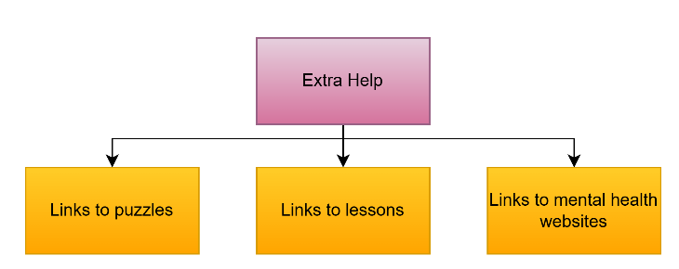
The Extra Help section will provide the user with the ability to improve their chess beyond what is capable with the scope of this project or improve mental health.
The links to puzzles and lessons will be links to either Lichess puzzles or YouTube videos where players can follow along and practice / learn chess.

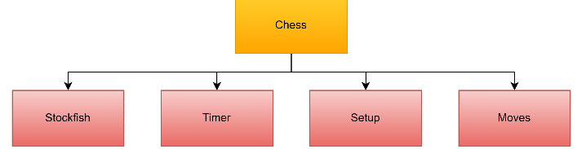
The Chess game allows the user to play classic chess with the ability to play timed chess and analyse game with Stockfish.
The Timer section is required to complete success criteria #6. This timer will start for white as soon as the game starts and alternate between being paused and running every time a player makes a move. This brings a sense of urgency to the game and prevents players from abandoning the game and wasting the other player’s time. This can be solved by importing the time library from python. When the time reaches 0, the game ends with the person who runs out of time losing (or drawing if their opponent lacks sufficient checkmating material).
The Setup section is required to complete success criteria #3 as it will include the creation of the board and the pieces in the right places. This can be solved by using Py Game to create the board, which will be interactive.
The Moves section is required to complete success criteria #4 and #5. It will allow the player to move the pieces to the squares the belong. It will also include the rules in terms of how the pieces can move, which will include check, castling and en passeant. This might be able to be complete with Py Game. I can also give each piece an identifier and the square that it is on. If the desired square is reachable for that piece, the identifier will move to that coordinate. This will involve decomposition to break it down into creating the identifier, setting the coordinates for each piece, setting the movement patterns for each identifier, etc.

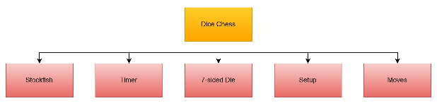
The Dice Chess section is almost identical to that of Chess section, with the only difference being the addition of the 7-sided Die. This die is required for success criteria #8. This will need number generation, a computational method, to simulate a dice roll. By listing numbers 1-7 then associating that with the piece that can be moved. This might require a dictionary to pair the pieces with the number that are rolled.
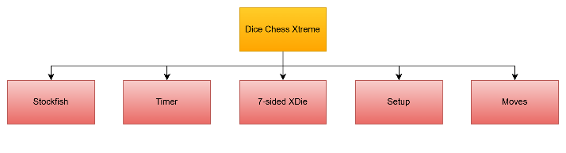
Similar to the Dice Chess section, this section has a 7-sided die, but the probabilities change based on the moves played in the game. This section will require the same stuff as the regular 7-sided die, but with a more complex algorithm using selection, as the probabilities are not constant.

Algorithms:

Chess:
The Chess algorithm will be the largest algorithm in the project. It allows players to play regular chess. It will be reused for both Dice Chess and Dice Chess Xtreme instead of writing a whole new set of code to save time. It will account for the setup, rules, timers and analysis. The solution would be impossible without this algorithm as there would be no games to play.

Tutorial:
The algorithm of the tutorial algorithm will be in a slideshow format for the most part where players can click to move to the next slide. It will probably require a list of slides. This will be efficient as I can use a for loop to display each slide. However, I will try to put some interactive activities for the movement of the pieces. This will be essential to players truly understanding the game well.
Pseudocode:
#img1, img2, ... represent the list of slides to be presented
images = [img1, img2, ...]
for image in images:
pygame.image.load(image)

Die:
The die algorithm is crucial for the dice chess variation. This will select a number from 1 to 7, which should each have an equal probability to be selected, then restrict the legal moves to that piece:
Pseudocode:
piece_list = [‘ ’, ‘N’, ‘B’, ‘R’, ‘Q’, ‘K’,] #List of the all notations
num = random.randint(1, 7) #Generates the random number
if num =! 7: #Only applies if the F4L number 7 hasn’t been rolled
for piece in pieces:
#Ensures that all of the pieces that are not the piece rolled have no legal moves
if piece.notation != piece_list[num + 1]
piece.legal_moves = []

XDie:
Similarly to the die, the xdie algorithm is crucial for the dice chess extreme variation. Based on the conditions for the game, it will generate and remove certain numbers from the list of numbers (duplicate numbers will occur) to change the probability.
Pseudocode:
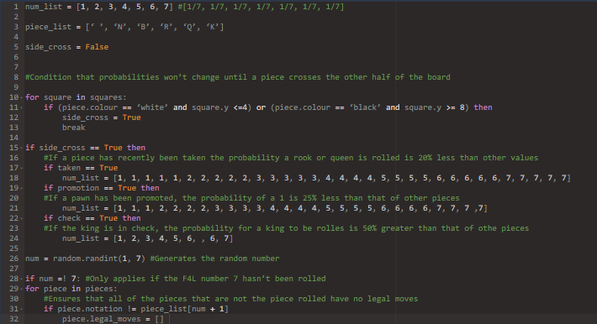

Structure of the solution:
The solution will be constructed in this order:
- The normal chess game
  - The initial set up of pieces
  - Movement patterns (including legal moves, checks, castling and en passeant)
  - Switching turns
  - Timers
  - Winning / drawing conditions
  - Stockfish
- Dice Chess
  - Copy of the normal chess game
  - Die
- Dice Chess Xtreme
  - Copy of the normal chess game
  - XDie
- The main menu
  - Title
  - The buttons for the game, tutorial, extra help and settings
- The tutorial
  - Slides
  - Activities
- The additional help
  - List of links
- Polishing the program

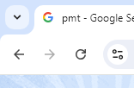
Usability features:
- Return Button: A return button will allow a user to return to a previous page without having to go back to the start and navigating the page all over again. An example of this can be seen on the right. The circled button allows the user to return to the previous page without having to search it up again or remembering the URL. This will make the program easier to use as it will make the interface easier to navigate. This, in turn, helps achieve success criteria #9.

- Colour scheme: Giving the user the choice between a light and dark colour scheme will be useful in helping them use the website better. Many people, such as my Stakeholder Efe, prefer a dark theme. Not only is it less strain on the eyes, but it is more aesthetically pleasing. However, some people may prefer a light colour scheme. When you consider that light is the default scheme for most websites, it makes sense that many people would be used to this theme. Therefore, I shall make both themes accessible to make the website as pleasing as possible.

- Graphical / Minimalistic Interface: A graphical user interface is essential to completing the website. The user needs to interact with not only buttons to access the game, but also the pieces in the game. This will require symbols, images and icons for the user to interact with. As a result, adding a GUI is non-negotiable to completing the solution.

- Toggleable settings: The settings will be easily accessible to player, as it is important that they are comfortable with their experience of the program. The settings will include colour schemes, board design, and features of chess like pre-moving and castling confirmation.

- Login: The login feature would allow users to have their own separate private accounts. This would allow them to adjust and save their toggleable features for the next time they enter their account, allowing them to efficiently get back to using the program without adjusting the settings every time. It would also allow their notes, analysis and games to be private and stored on that one account forever. This will make users more comfortable using these features.

- Tutorial for first-time users: First-time users may need help navigating the website, regardless of their chess experience. This feature was recommended by my Stakeholder Henry. This would prevent users from getting lost in the program and getting frustrated.

Key data structures:
Structure | Structure name | Description | Justification | Validation
Variable (List) | tutorialSlides | The tutorial will mainly be a list of slides. This list will contain the slides that the user can browse through | This list will allow the user to switch between slides with less memory used. It will also be easier to code and debug as opposed to writing separate code for each individual slide. | N/A
Variable (List) | extraHelpLinks | The extra help is links can be put into this list, which the user can select from | The extra help links can be displayed using a for loop, reducing the number of lines of code necessary and making the program more efficient. | N/A
Variable (List) | move | Contains the desired move as a list. Consists of the file, then the rank the player wishes to move to: [a,5], [e,4], [g,6], etc. Not only will is have to be a list of size 2, but the files need to be in the range(a-h) and the ranks in the range (0-8) | This will be necessary in many other functions that help facilitate the move the player wishes to make. | if len(move) == 2:  if ord(move[1]) >=97 and ord(move[1]) <= 104:  if move[1] >=1 and move[1] <=8:  legal_Moves()  #Function the be explained later
Variable  (Integer) | die | Contains the number rolled on the die | Since this is a variable, I can easily change the value stored in between dice rolls. | if int(die) != die:  print(‘Invalid value’)  else:  ...  #rest of code
Variable (Integer) | xdie | Contains the number rolled on the xdie | Similarly to the die variable, this variable can easily store and output the value of xdie rolls. | if int(xdie) != xdie:  print(‘Invalid value’)  else:  ...  #rest of code
Dictionary | diceVal | Each piece will have an assigned dice number associated with it. The piece will be the key while its dice value will be the dictionary value. | Using a dictionary to pair these together will be useful as it makes it easier to link them. | N/A
Dictionary | pieceCoord | Each piece will start off on a square. This piece will be the key while the coordinate will be the dictionary value. The coordinates will be expressed in algebraic notation, likely as a list:  [a,1], [b,4], [h,6], etc. | This dictionary is important for the code to navigate where each piece is. Without this dictionary, it would be impossible to determine where each piece can move, making the function legal_Moves impossible to compute. | N/A
Dictionary | materialVal | Each piece has a certain value as a piece (which is not related to its dice value). These were explained in the analysis stage. | This dictionary is important for players to analyse their games accurately since material is one of the most important factors winning in a chess game. | N/A
File | moveStorage | This file collects and permanently stores the moves made in algebraic chess notation, whcih can be viewed later by the user. | This file is essential for success criteria #7 as it allows users to store the moves they played in algebraic notation. This allows them to review their games whenever they want, helping them improve their skill. | N/A
File | noteStorage | This file allows users to create and store notes that they may want to keep, including mistakes they need to watch out for and things they did well. | The players should be able to come back and review their notes at any time they want, which this file will allow. | N/A
Function | diceRoll | This function uses the die variable to simulate the dice roll. As a result, random number generation is essential in the form of the ‘random’ library. | This has to be a function and cannot be repeated because chess games technically could go on for thousands of moves. This function will make it easy to apply a while loop and fix errors. | N/A
Function | xdiceRoll | This function uses the xdie variable to simulate the dice roll. As a result, random number generation is essential in the form of the ‘random’ module.  It will also have conditions for which probabilities change. | Similarly to dice_Roll, this function can be put in a while loop and is easy to debug. The function will also contain selection as the probabilities are dependent on the moves made in the game. | N/A
Function | legalMoves | This function enforces the game’s rules (not including 3-fold repetition, 50 move rule, mates and timers). | Without this it would be impossible to complete success criteria #4. Without this function, the white player will be able to take the opponent’s king in the first move, ruining the game’s benefits and fun.
Class | Square | This class helps design the squares of the board. This includes the colours, dimensions and orientation | This class allows me to easily add features of the squares without affecting the rest of the algorithm. It also makes it easier to debug and errors that may arise. | N/A
Class | Piece | This class sets the movement patterns, initial arrangement, appearence and material values for each piece. | Classes allow for many methods that may prove useful when designing the attributes to the pieces. | N/A
Class | Timer | This class sets how timers will be applied to the games that are played, including increments. This will require me to import the ‘time’ module. | Classes will allow me to easily choose when to apply the timer. This makes it easier to debug code if I failed a test in the program. | N/A

Test data
Category | Test type | Nº | Test data | Justification | Expected Result
Board | Valid | 1 | Loading the board and pieces | This is the most important test. Without the board and pieces setup correctly, the game cannot be played at all. | The board is oriented and designed perfectly with accurate coordinates. The pieces are set up correctly from both white’s and black’s perspective.
Movement | Valid | 2 | Moving each piece in the way it’s supposed to be moved without taking a piece. This includes:  Moving pawns forward one square each move (optionally 2 for their first move)  Moving knights in an L-shape  Moving bishops diagonally  Moving rooks vertically and horizontally  Moving queens vertically, horizontally or diagonally  Moving kings 1 square in each direction | This will confirm that each piece has been coded to move in its designated movement pattern. It also confirms that the game data will be stored for later, which will also apply to tests 3 and 4. | The algorithm allows the move and switches to the other player’s turn, while storing the move in a list
Movement | Valid | 3 | Moving each piece in the way it’s supposed to be moved by taking a piece. This includes using all the movement patterns on the previous test, except for pawns, which should be able to capture diagonally and En Passant. | This will confirm that opposing pieces are able to capture pieces, being accepted as legal moves. | The algorithm allows the move and switches to the other player’s turn, with the opposing piece removed from the board while storing the move in a list
Movement | Valid | 4 | Trying to castle with conditions that allow it – moving the king 2 squares in either direction with appropriate conditions | This will confirm that castling will be permitted, and the program will ask for confirmation to ensure the user is OK with their decision | The algorithm asks the user to confirm whether to castle or not. If yes, the castle is permitted while storing the move in a list. If no, the user can pick another move
Movement | Invalid | 5 | Moving each piece in a way it should not ever move. This involves moving a piece in a way that doesn’t match with the specifications of Test #3. | This ensures the movement pattern of the pieces have been properly assigned and cannot be moved in any random manner, which would be illegal | The algorithm cancels the move and lets me pick a legal one.
Movement | Invalid | 6 | Trying to capture my own piece | Ensures that pieces of the same colour cannot attack one another, which would be illegal | The algorithm cancels the move and lets me pick a legal one.
Movement | Invalid | 7 | Trying to move the king into check | Ensures that the king cannot enter check (an illegal move) and the king cannot be capture on the next turn (which would break the rules of chess) | The algorithm cancels the move and lets me pick a legal one.
Movement | Invalid | 8 | Making the move that would leaving the king in check |  | The algorithm cancels the move and lets me pick a legal one.
Movement | Invalid | 9 | Trying to castle in check |  | The algorithm cancels the move and lets me pick a legal one.
Movement | Invalid | 10 | Trying to castle in un-castlable conditions:  - Pieces between rook and king  - King crossing over squares that would leave it in check  - King has moved  - Rook has moved | Ensures that players cannot castle however they want, and requiring the right castling conditions | The algorithm cancels the move and lets me pick a legal one.
Switching turns | Valid | 11 | Making a legal move against a player | Ensures each player gets an equal amount of turns to avoid inequality | The turn switches to that of my opponent
Ending the game | Valid | 12 | I checkmate my opponent | Sets the most common winning condition for the game | The game ends, announcing me the winner and the opponent the loser
Ending the game | Valid | 13 | My opponent’s timer runs out while I have sufficient checkmating material. | Brings integrity to the time pressure, as it can have an impact on who wins, regardless of the position
Ending the game | Valid | 14 | My opponent resigns | Allows opponents to resign if they don’t want to play anymore or have an urgent task
Ending the game | Valid | 15 | I stalemate my opponent | Sets the most common drawing condition. The game ending in stalemate prevents the king from being captured, which breaks the rules of the game. | The game ends, announcing the game to be a draw
Ending the game | Extreme | 16 | The same position occurs 3 times  This will involve moving two opposite-coloured knights back and forth until the starting position is reached 3 times, including the initial position. | Respects the three-fold repetition rule. Boundary test because this should not occur after the same position occurs twice | The game ends, announcing the game to be a draw
Ending the game | Extreme | 17 | My opponent’s timer runs out while I have insufficient checkmating material. | Sets another drawing condition, which bring some common chess tactics into my solution. Boundary test because this should not occur if there is 1 second remaining or if there is any sufficient material | The game ends, announcing the game to be a draw
Ending the game | Extreme | 18 | Both me and my opponent run out of sufficient checkmating material:  K VS K  K & N VS K  K & B VS K  K & N VS K & N  K & B VS K & B (Bishops on same colour squares)  A game will be played for each aforementioned  scenario | Prevents players from being stuck in a game when there is not set of possible moves for a win or loss | The game ends, announcing the game to be a draw
Ending the game | Extreme | 19 | Me and my opponent agree to a draw | Allows two players to end a game early if they are both stuck in a position or are busy with an urgent task. | The game ends, announcing the game to be a draw
Timer | Valid | 20 | Player starting a game | Sets the timer for the game, starting for white | The timer is set at the chosen time, running down for white, but not starting for black
Timer | Valid | 21 | Move is made with time conditions | Allows players to experience a proper chess timer | The timer pauses for the player who made the move (and increments but the desired amount if necessary) and runs for the other player
Stockfish | Valid | 22 | Input a game based on its list of moves in algebraic chess notation | Allows players to analyse their games to improve upon them | Stockfish receives the game’s moves in algebraic chess notation and analyses the game based upon that, providing an evaluation of the position and the best next move
Dice | Valid | 23 | I move the piece that corresponds to what the die lands on | Allows the die to influence the piece the player can move, which is the whole premise of this variation | The algorithm allows the move and switches to the other player’s turn
Dice | Invalid | 24 | I move a piece that doesn’t correspond to what the die lands on | Prevents players from breaking the rules of this variation, and making them subject to the die | The algorithm cancels the move and lets me pick one with the selected piece.
XDice | Valid | 25 | I move the piece that corresponds to what the xdie lands on | Allows the xdie to influence the piece the player can move, which is the whole premise of this variation. | The algorithm allows the move and switches to the other player’s turn
XDice | Invalid | 26 | I move a piece that doesn’t correspond to what the xdie lands on | Prevents players from breaking the rules of this variation, and making them subject to the xdie | The algorithm cancels the move and lets me pick one with the selected piece.
XDice | Valid | 27 | Checking and outputting the probabilities after each roll, as well as performing calculations on my own calculator to compare them | Ensures the probabilities are being properly adjusted based on the moves played. | The probabilities displayed and the probabilities calculated are approximately equal (allow a 0.02% uncertainty due to rounding errors)
Menu | Valid | 28 | Opening up the program | Ensures a menu is present that can allow for players to navigate the program | Main menu appears, with clear options that the user can go to.
Menu | Valid | 29 | Hovering over a button | Allows players to see what button they are going to press before they press it | A coloured box lights up around the button’s area
Menu | Valid | 30 | Clicking the “Games” button | Ensures that the user can choose to play a game and select which one. | Takes the user to a screen where they can choose the options for the games they want to play
Menu | Valid | 31 | Clicking the “Tutorial” button | Ensures users can easily see the tutorial slides | Takes the user to the tutorial slideshow
Menu | Valid | 32 | Clicking the “Settings” button | Allows the user to customise the user interface to their liking. | Take the user to a screen where thay can control how the game is displayed to them.
Login | Valid | 11 | Entering a suitable match for a username and password | This allows players to access their accounts, provided they input the correct combination of username and password | Gives the user access to the main menu, allowing them to use the program
Login | Invalid | 12 | Entering a username and password combination that is unsuitable | This prevents unauthorised player from accessing peoples’ accounts, allowing for security | Asks the user to try again, without giving them access to the main menu

Post-development Survey
After the solution is developed, I will conduct a survey for my stakeholders that will determine how successful my solution is.
Post Development Survey
The first 7 questions link to each of the requirements for the solution to work:
- Ensures the users could benefit from an online feature.
- Allows me to see if there is a lapse in the way I created the move set.
- Allows me to see if the chess engine was correctly implemented in the game for past-game analysis.
- Logging in is required for multi-platform gameplay. This question lets me know if I implemented it correctly.
- Ensures the main menu allows the user to navigate the program with ease.
- Ensures the elements of the game are visually appealing to the user.
- Ensures the gameplay is simple to use and understand.
The 8th question lets me know how they find the program as a whole to see how a regular user would enjoy it. This allows me to gauge if it would bring value to the chess community.
The final question leaves me with feedback on how this can be improved in the future.

Development

Prototype 1 – Chessboard:

Square Class:
For my first prototype, I used Py game to generate a black and white chess board. For this, I will introduce a class called Square to generate the squares and their colours.
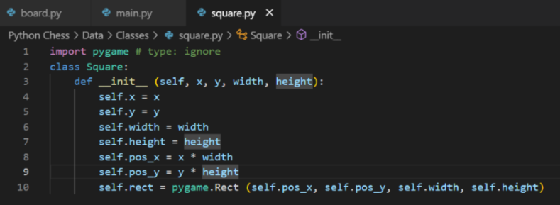
This class takes the width and height of the squares, as well as their x and y coordinates, all in terms of pixels. The pos_x and pos_y attributes determine the actual position of the square. The reason they had to be multiplied by the positional and dimensional parameters is to ensure that the squares do not overlap.

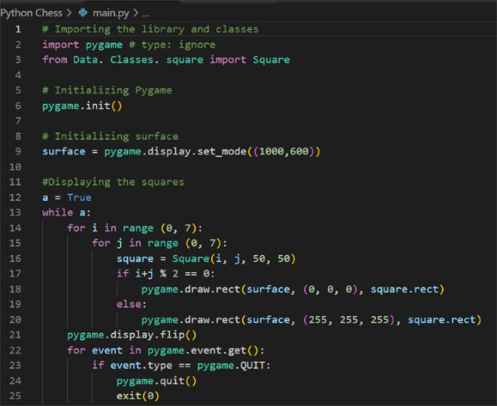
This code imports the Square class from another file in the project folder, as well as the library Py game to allow us to display the squares. The while loop ensures that the display remains open for an extended period, as it will otherwise run for only one frame. The first two for loops allow me to alter the colour of the colour of the squares by their i and j values. That is the primary purpose for these values. The final for loop allows me to display the Py game screen for an extended period of time, otherwise it would just display for 1 frame. In this, there should be 64 squares displayed, with no overlap and alternating colours. This is the result of the code:
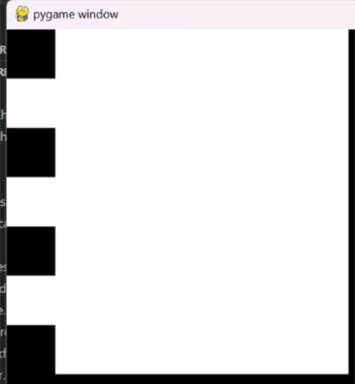
This output shows that the squares only alternate on the first column, but not on the other columns or any of the rows. Additionally, there seems to be only 7 rows rather than 8, meaning this code would output only 49 squares instead of 64.

After analysing my approach, I decided to use a different method of selecting the colours.
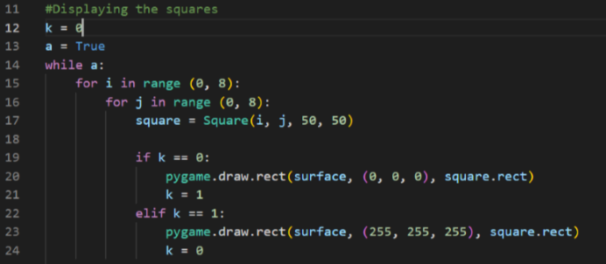
In this variation, the value k alternates between 1 and 0 for every square generated, changing the colours, alternating between white and black:
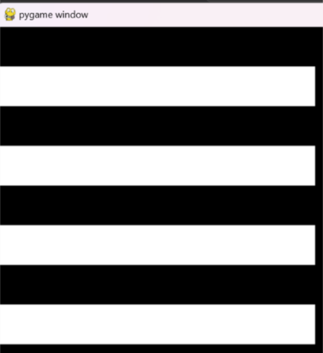
This approach was flawed though. The screenshot shows rows with alternating colours rather than individual squares. Upon further analysis, I realised that on a real chessboard, when reading it like a book (or embedded for loop), there will be consecutive squares of the same colour, even though they aren’t directly touching. This will mean we need the same value of k to cause a different outcome on different rows.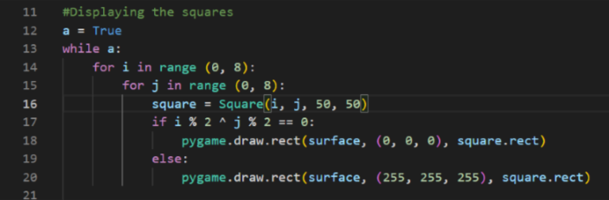
Finally, I came to the solution for the chessboard. I got rid of the k variable and went back to using purely the i and j coordinates. This time I found if i and j are both even or both odd, the colour of the square will be black, but if one is even and one is odd, it will be white. I used this information in the following code to create an appropriate model for the chessboard:

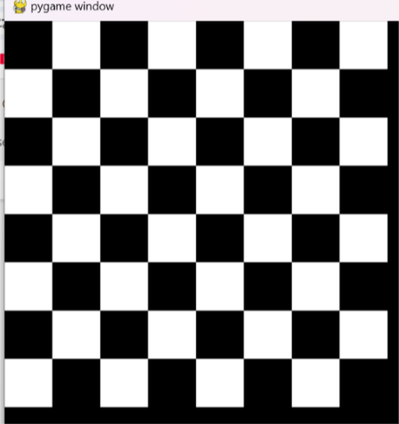
In order to simplify and tidy the code, I decided to place the colouring aspects as a part of the Square() class, as well as add some other features of the squares: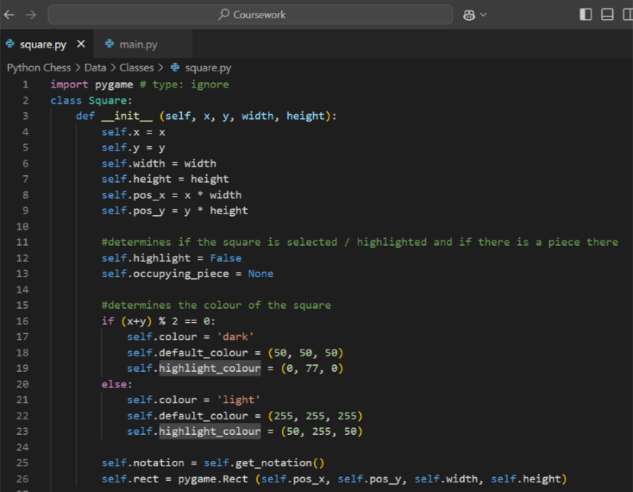
This class includes feature such as the square’s dimensions, position, colour, what piece (if any) is occupying it, etc. I also added the colour for if the square was highlighted (dark green if (x + y) is even, light green if (x + y) is odd). This highlight would be used to show what moves a piece can make later on. It should be noted that the colour for dark squares in this code will be a dark grey rather than a pure black due to my stakeholders’ preference.
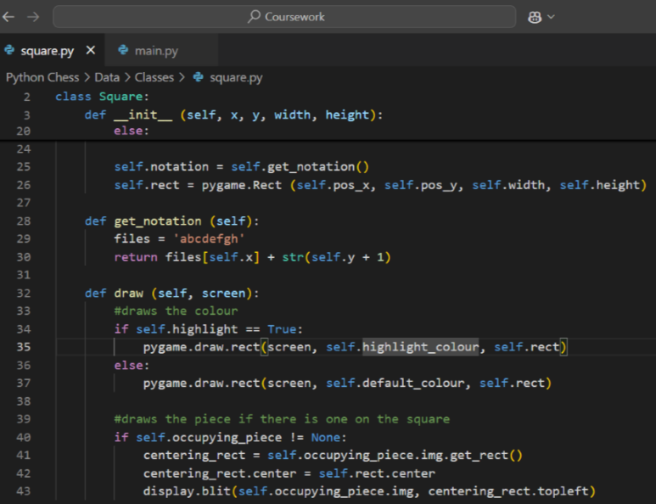
The get_notation() function returns the coordinates of the square in algebraic chess notation by taking the self.x and self.y values. The draw() procedure takes the Py game screen that is being displayed on to actually draw the square.
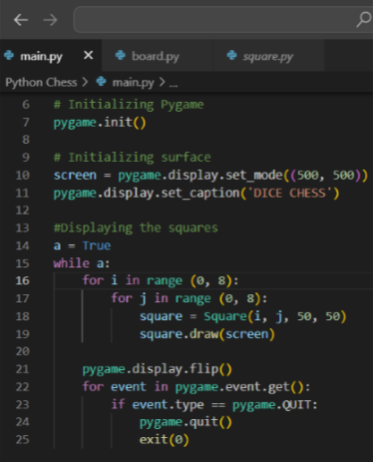
This loop is similar to the one in the previous version, except more simplified to use the new and improved Square() class. It also produces the same result:
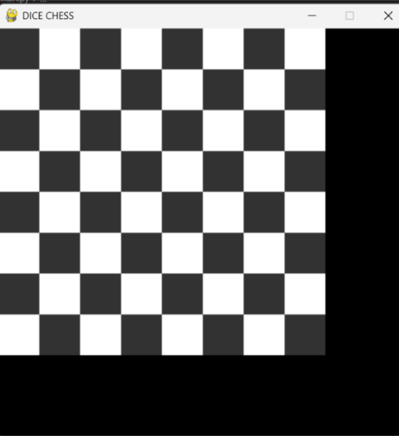

Next up is the pieces on the chessboard. To do this, we need the images to be used for each and every piece. These images have been gathered in the folder that the workspace will be used in, so it is easier to use them. This next part is based on the internal workings and rules of the chessboard, rather than designing individual squares. This means the Square class would not be appropriate for this. We’ll have to introduce a new class: Board. This helps with the function of the board, rather than the design.

Board Class part 1:
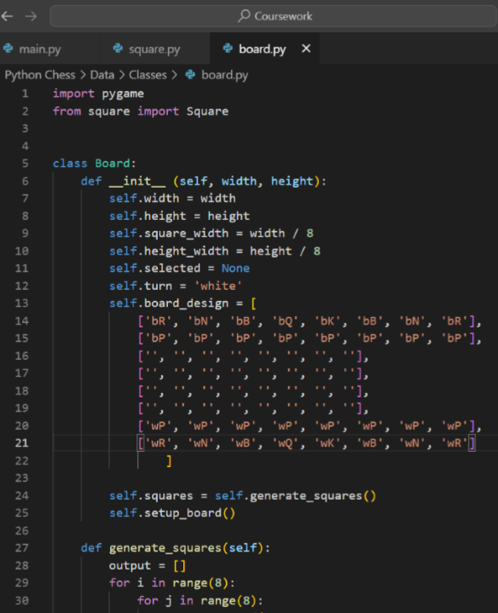
The part we need to focus on for this prototype is self.board_design, which describes the way the board is structured in the perspective of white. The notation of the pieces tells us the colour followed by the type of piece
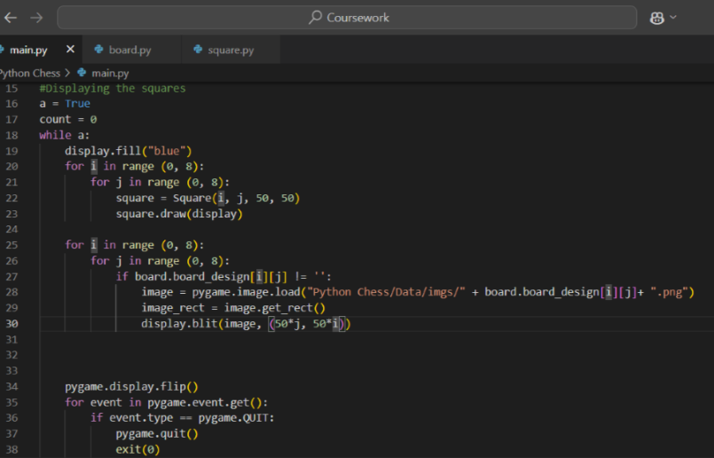
Using this 2D list, I can display each of the pieces from the image file with equal spacing between them. However, I had to shift the board by 5 pixels in the Square class for them to fit on the board properly:
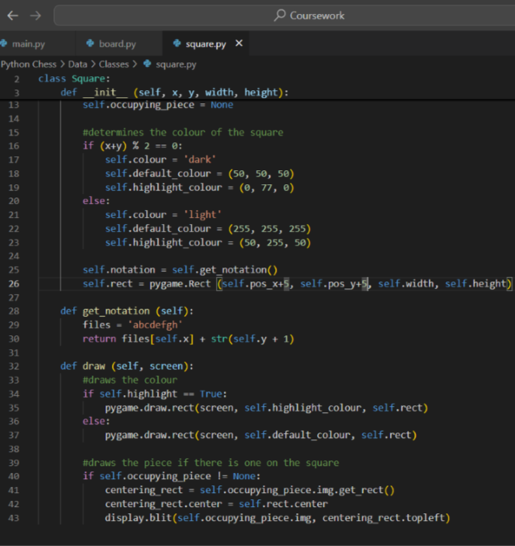
This is the result:
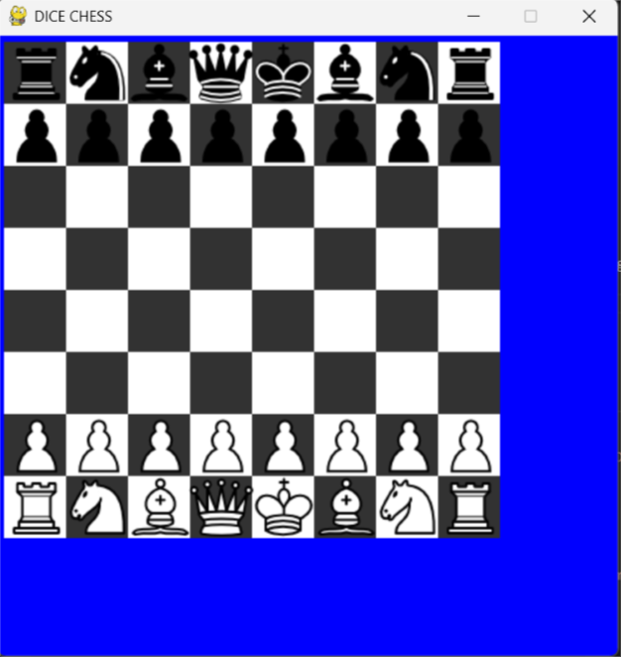
This concludes the first prototype.

Stakeholder input:
Upon finishing this prototype, I showed it to my stakeholders for any feedback on how to improve it further. This was their input:
- Henry - “The pieces fit on the board and don’t overlap with each other, so I’m fine with it. The boards I usually play with are online so trying to read moves would be difficult.”
- Michael - “The board looks a bit cramped. The pieces barely fit on their squares, and it looks a bit odd. There aren’t any coordinates, and I’m put off with the blue background. The pieces are arranged fine though”
- Efe - “The way the pieces fit on the board looks really weird, but apart from that, it looks fine.”
The main critique of this prototype is that the pieces are disproportionately big compared to the squares. For the next prototype, I will adjust this by resizing the images. Additionally, I mistakenly made the colours the wrong way round, although none of my stakeholders noticed that. That will be fixed in the next prototype.

Prototype 2 – The working gameplay:

Board Class part 2:
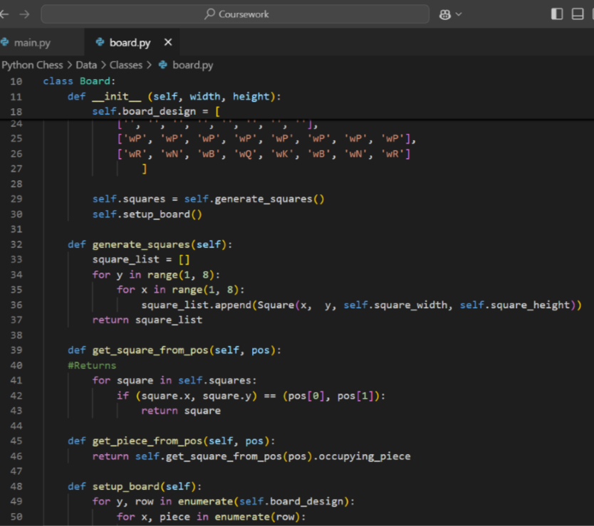
Continuing with the Board class, it takes the desired width and height of the board, then divides if by 8 for the dimensions of each square. It also includes whose turn it is and what piece is selected. It keeps its setup of the pieces from Prototype 1. It also creates a list of the squares as objects and stored them in a list.
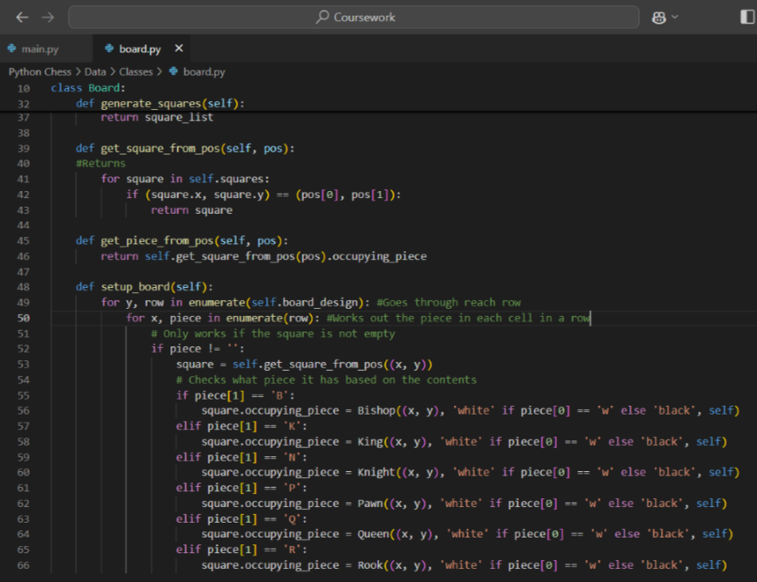
This class also uses a few methods:
The function generate_squares simply creates a list of the squares to be printed, including their coordinates and length, then returns that whole list.
The method get_square_from_pos takes in the list of positions. If the x and y coordinates of the squares match the positions, it returns the square.
The method get_piece_from_pos returns the piece occupying the returned square in the previous function.
The method setup_board sets what piece, if any will be on each square based on their colour and type. Squares with an empty string will simply have no piece on it.

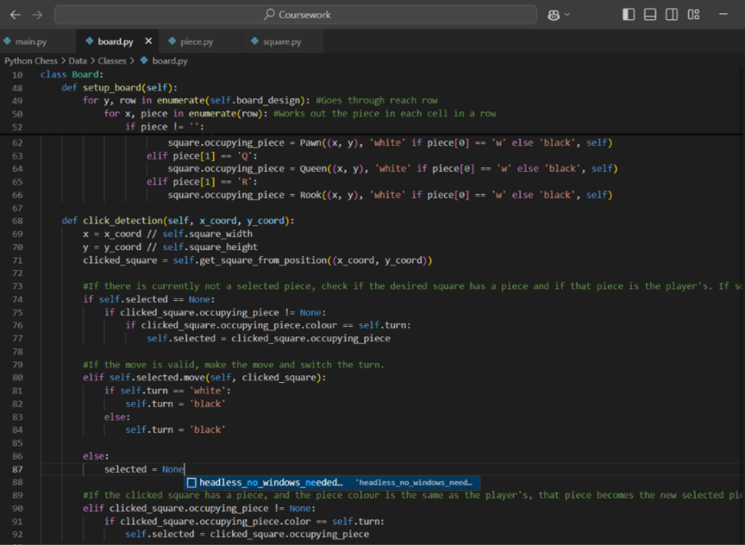
The procedure click_detection detects the square that has been clicked and forms an appropriate response:
- If the player hasn’t currently selected a piece, the clicked square has a piece and that piece belongs to the player, that piece is selected, shown by its square and available moves being highlighted.
- If the player’s click makes a valid move, that move is made and the turn switches with all pieces being deselected.
- If the player has already selected a piece, but clicks on another piece of the same colour, that piece becomes the selected piece.
- If the player clicks anywhere else, all selected pieces (if any) are deselected.

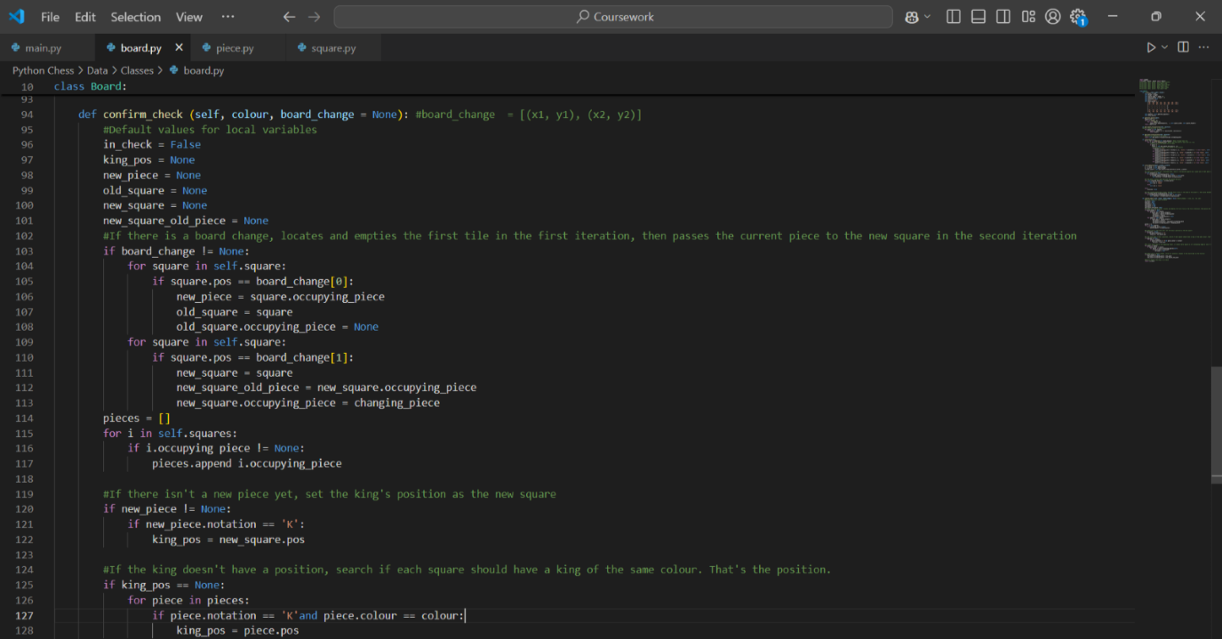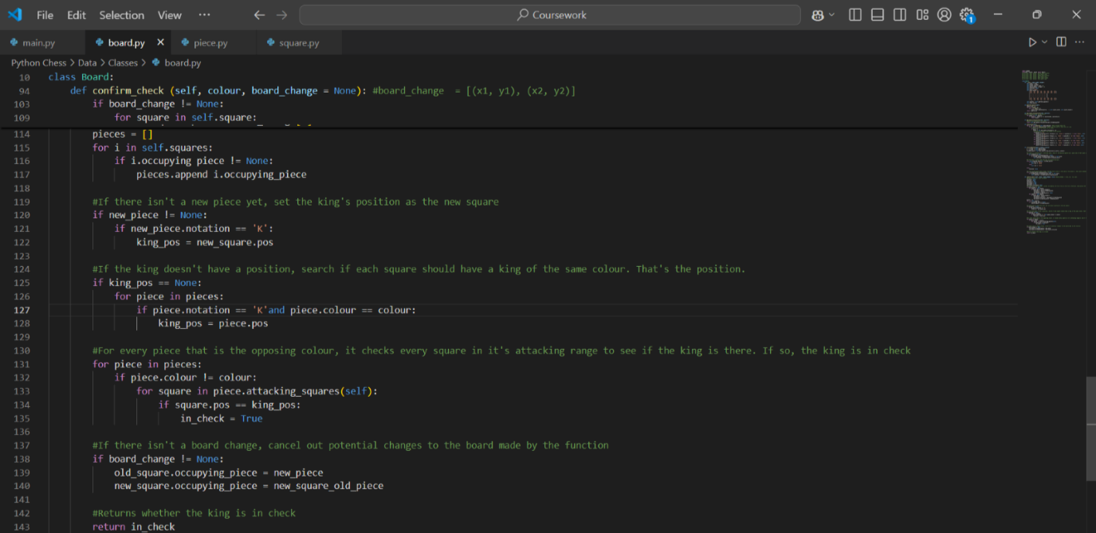The confirm_check() method does a series of operations that determine whether the player is in check or not. This is necessary for Requirement #2, where a player can only make certain moves in chess if they are in check.

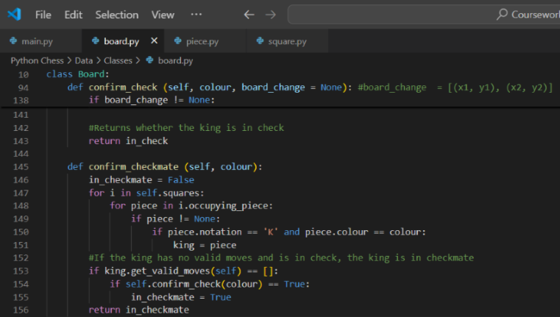
The confirm_checkmate method, like the previous one, uses a series of operations to determine if the player is currently in checkmate. This is also needed for Requirement #2. This is likely an imperfect model for now since it only looks at the king’s valid moves and doesn’t consider blocking or capturing the checking piece.

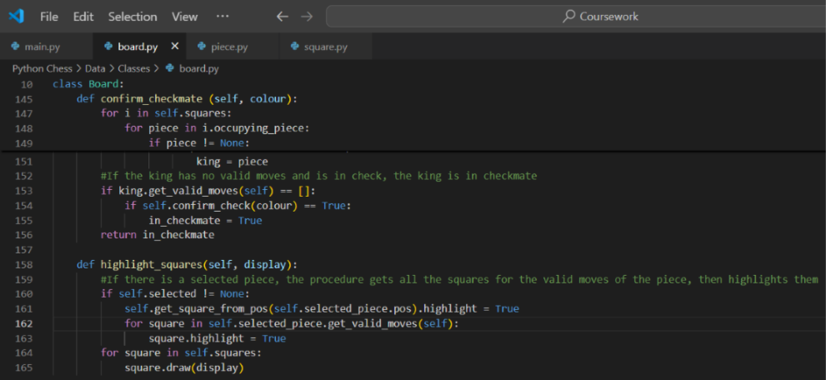
The final subroutine for this class is the highlight_squares class. This is for Requirement #7, which allows players to see which moves they can or cannot make. This will simplify the gameplay and improve the success of this project. This procedure simply highlights every single square that a player can move a piece that they selected, as well as the square the piece is occupying.

That concludes the Board() class and need a class for each piece. However, we first need a parent class for them to reduce redundancy as a lot of their logic would be repeated. This parent will be called Piece.

Piece Class:
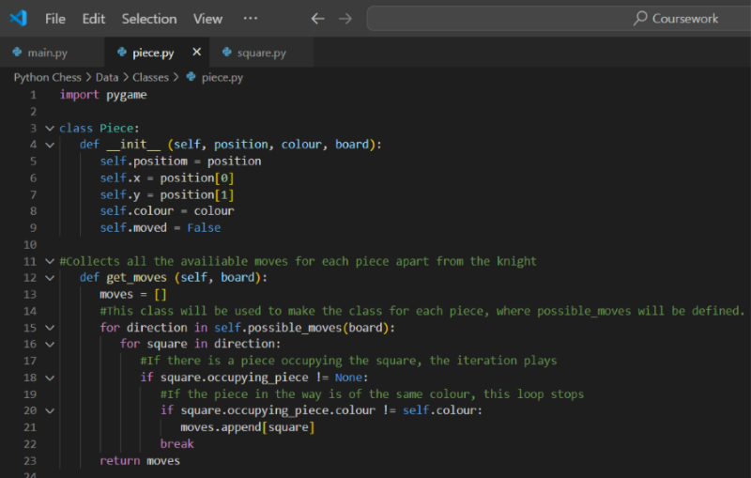
The Piece class creates properties that are shared between every piece. For example, no piece can move a move outside of its movement pattern. The current attributes of the class create the position of the piece, as well as the coordinates, colour and whether it has moved yet (this will be important for castling and en passeant which are part of Requirement #2).
The get_moves() method takes all the directions a piece can move then checks to see if there is a piece in every square of that direction. If there isn’t or there is one of a different colour, that square is available for the piece to move to. For the latter condition, the other squares in that direction will not be checked for potential moves. This is necessary for Requirement #2 as it determines which squares and what moves each piece can go to. However, this will not work on the knight. This is because it does not move in a cardinal or ordinal direction. It also cannot be blocked. Another function likely will have to be used for the knight.

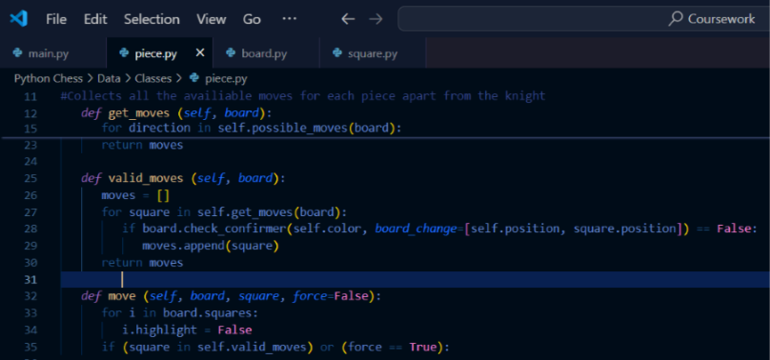
The valid_moves method returns if the player would be in check if they moved a piece to a certain square, then returns the valid moves based on that.

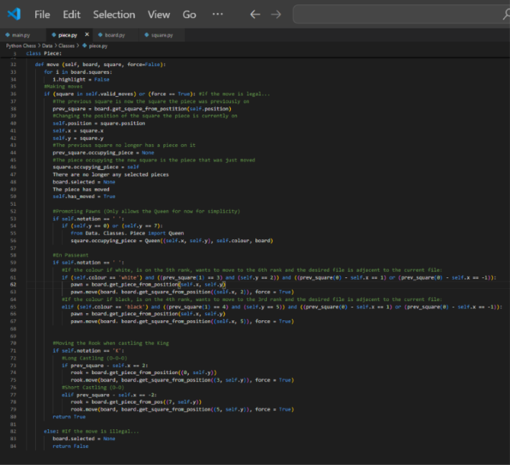
The move method returns if a move is made or not to communicate with the Board class. This function considers castling, en passant and pawn promotion. The latter only considers promoting to a queen for simplicity, but other pieces will be added later.
The concludes the Piece class. Now we can create the child classes: the classes for each piece, starting with the Pawn class:

Pawn Class:
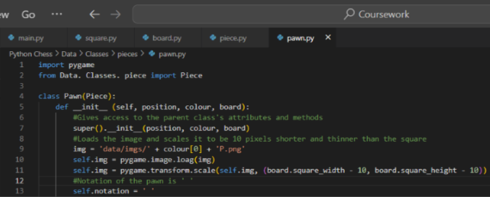
The current state of the class allows it to use the Pieces() class by using the super() method. It then creates and loads an image, scaling it to be slightly smaller than the tile it is on, as per my stakeholders‘ feedback. This is also necessary to complete Requirement #6 and scale the piece correctly. This will be common among the rest of the piece classes.

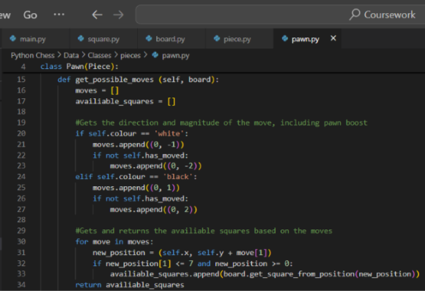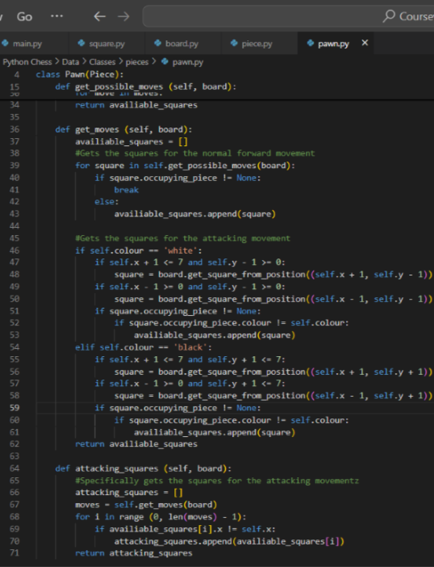
The get_possible_moves() and get_moves() methods are both responsible for getting the possible squares where the pawn can go. This will be important not only to ensure that the pawn cannot make an illegal move, but also to be able to highlight the possible squares. The attacking_squares() function exclusively return the legal pawn moves that result in the capture of an opposing piece to be used to limit king movement. Similar functions will be made for the other pieces as well.

Knight Class:
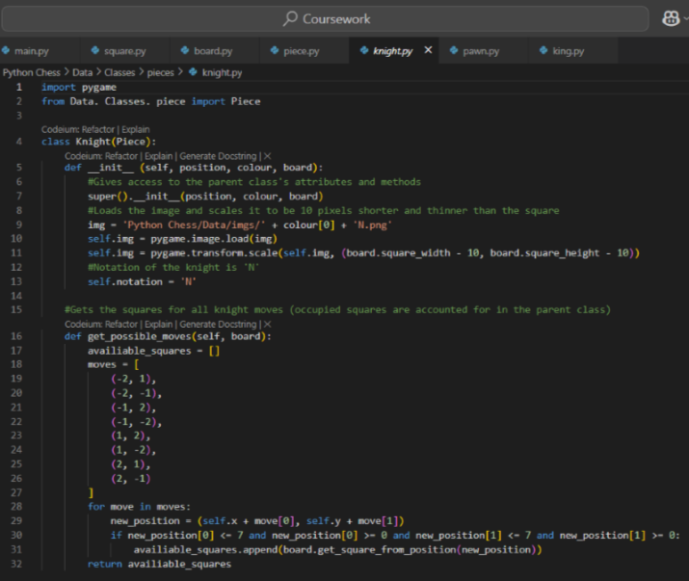

Bishop Class:
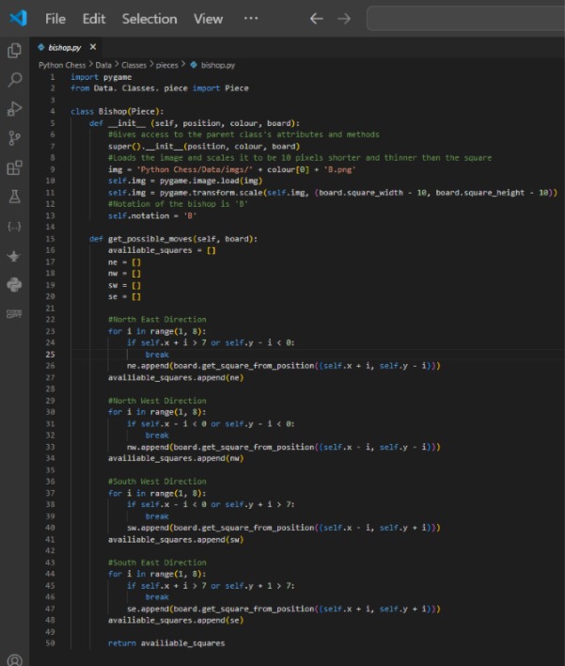

Rook Class:
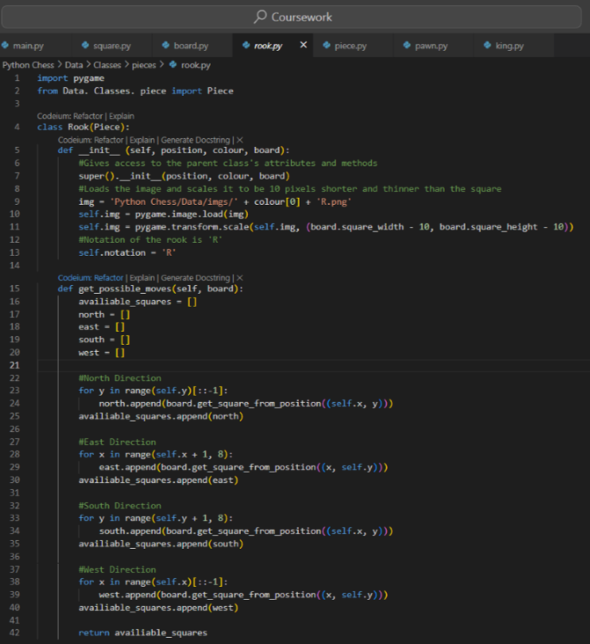

Queen Class:
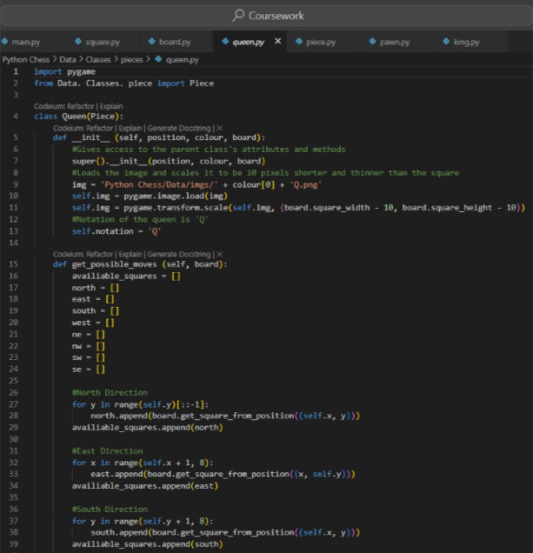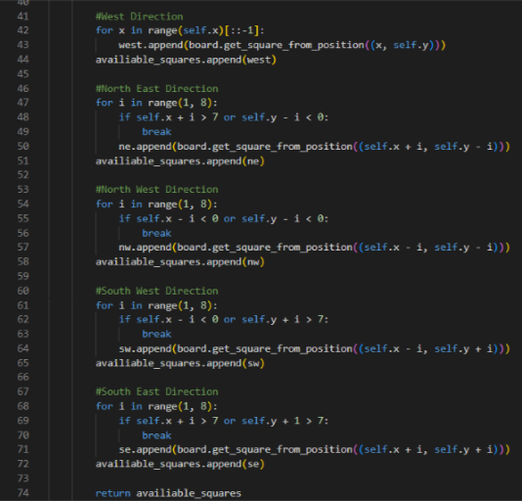

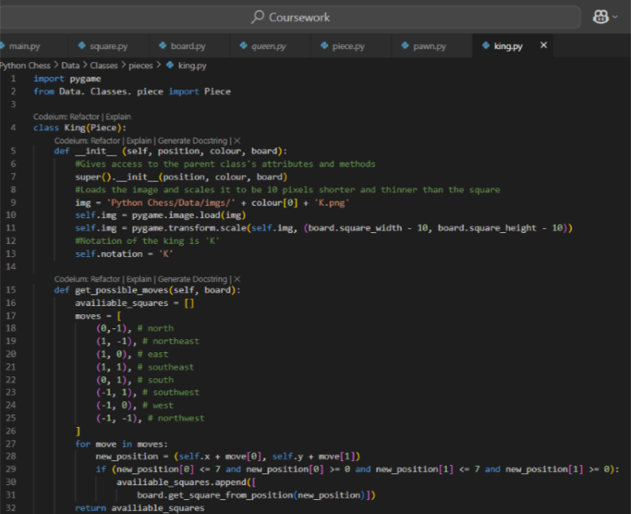
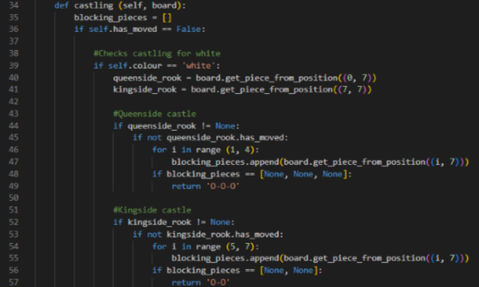
King Class:

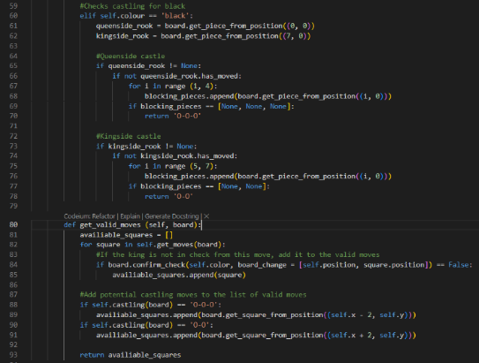

Finishing off:
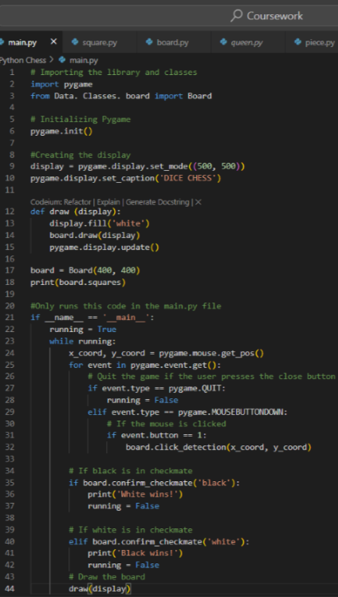
In the main.py file, I created a medium for the game to run, as well as making sure the game stops as soon as checkmate is reached. This helps to achieve Requirements #1 and #7 as they not only allow the user to see the screen and play the game but also make it simple by having the standard chess board and pieces. The result is shown below:
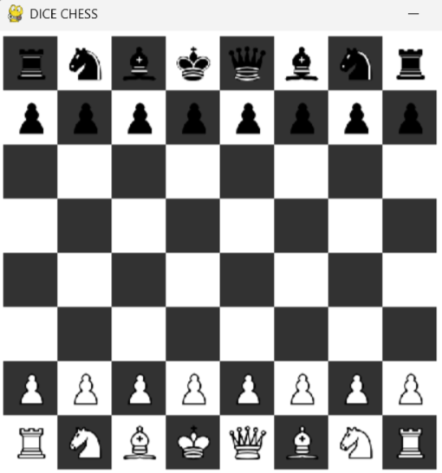
Once again, the test for the board and pieces works correctly, minus the coordinates.
Now I can run alpha testing & improvement to ensure my code works properly while fixing any problems along the way.

Testing & improvement:

Video 1
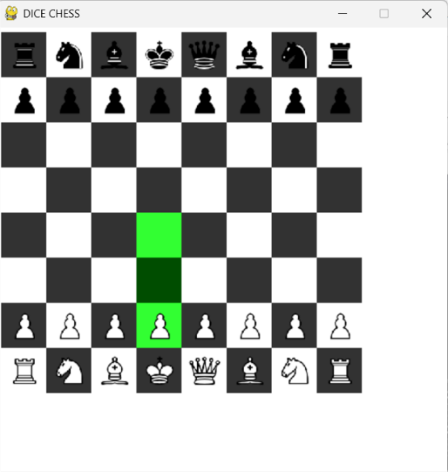
Upon clicking on the king’s pawn, two green squares in front of it show that pawn’s only legal moves. This also works for every other pawn:
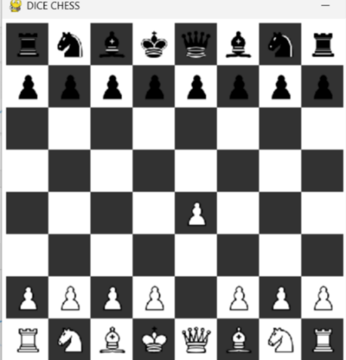
I am also able to move the pawn by clicking on one of the squares.
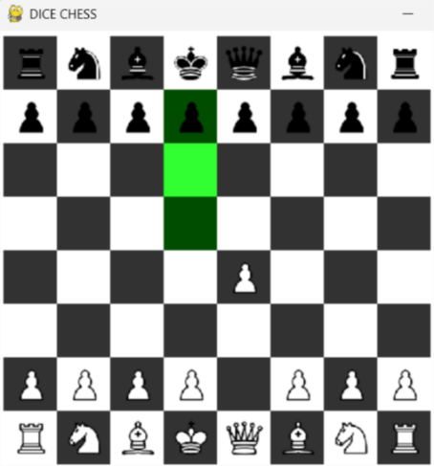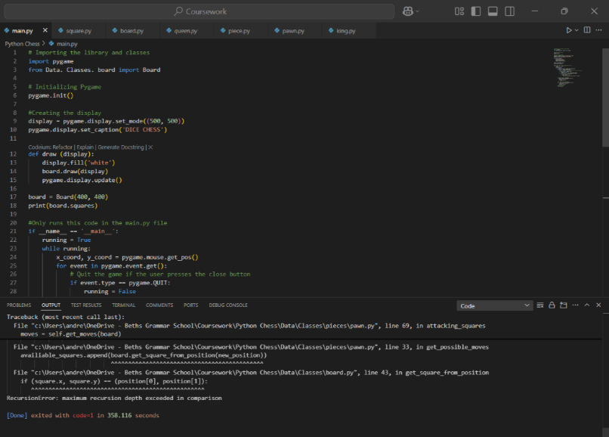
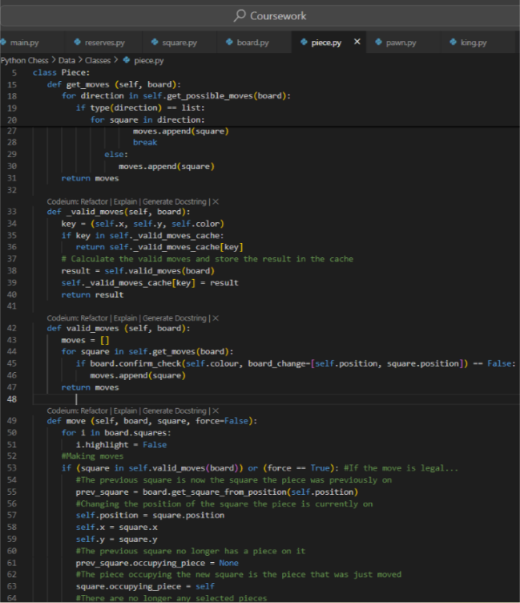
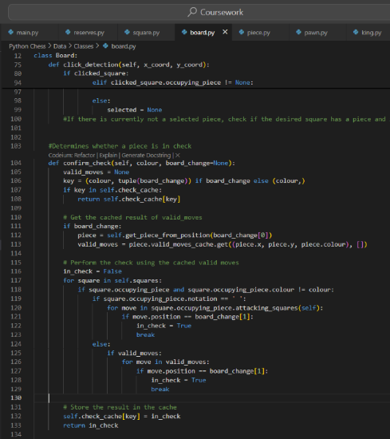
A similar scenario occurs for the black side; however, I am unable to move one of the black pieces. When I try, an error message comes up that says I have exceeded my recursion depth. This is likely because my program uses a lot of recursive functions with classes deep within each other. This problem must be fixed to meet Requirement #1 since it prevents black from making a single move.

The reason for the recursion was because the confirm_check and valid_moves methods call each other indefinitely, leading to a stack overflow. To correct this, I used caching to set a base case.

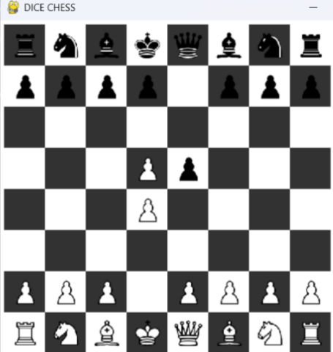
This position would have previously been impossible, but adding those methods allowed for more than one move to be made. However, whilst this does allow pieces to be moved multiple times, doing so creates a copy of the piece rather than changing its position. This would become very confusing and problematic, as not only would players not be able to tell what piece is real, but it would also allow players to capture the king, which is against the rules. Therefore, this problem must be solved to fulfil Requirement #7.
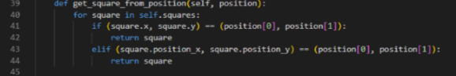
Despite this, I was able to fix the bug by adding the code in the lines 43 and 44 above in the Board class. The result led to pieces that can move without cloning themselves:
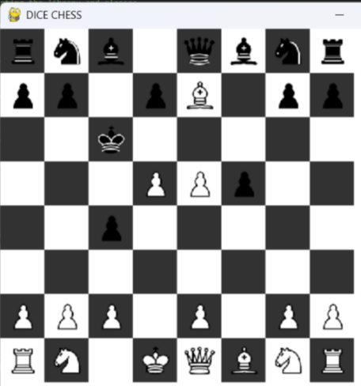
This setup of pieces is only possible by moving multiple pieces multiple times. Since there are no duplicates, and even some captures, this proves that the line of code works. However, this works for all pieces other than the knights.
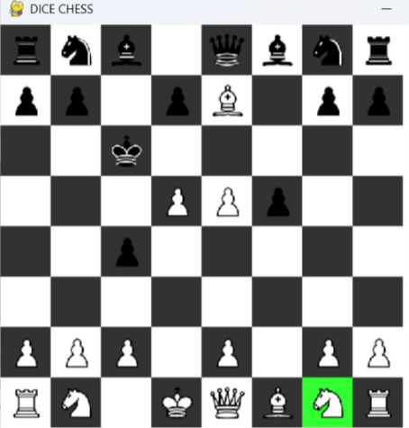
When clicking on the knight, its square lights up, but not the places it can legally go to. The player should be able to move the right knight to 2 squares in this position. The knight also does not move when clicking on its legal moves either since it can only move to highlighted squares. This must be fixed to meet Requirement #1.
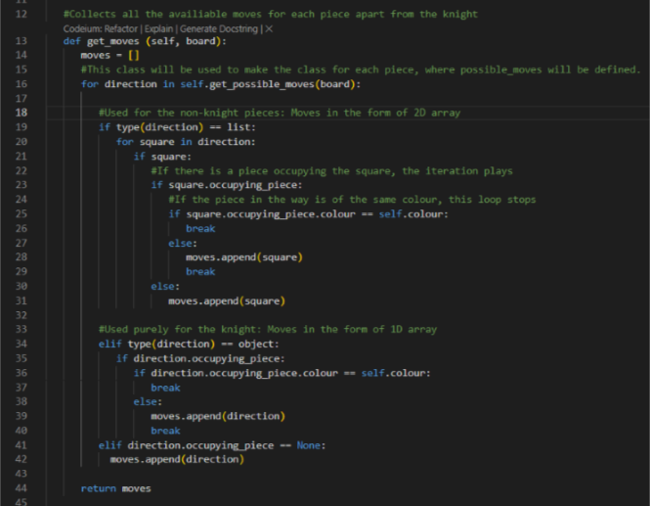
The mistake was that the other pieces’ moves will be in the form of a 2D array, causing each item to be a list, due to the directions, but the knight’s is in the form of a 1D array, causing its items to be an object. I simply allowed a different set of instructions if the piece’s move were in the form of a 1D array. As we can see below, not only do the knight’s legal moves get highlighted, but it can move to them as well.
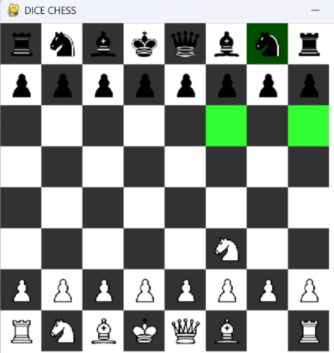

The white knight has moved form its original position, and we can see the black knight’s moves, showing that it displays the legal moves and move to them.

Now that the knight can move, and the other pieces can move normally based on previous screenshot, we can conclude Test #2 a success.

When moving onto Test #3, things get slightly complicated. Normal pieces can capture opposing pieces, and pawns can capture diagonally, however pawns can only capture diagonally in one direction:
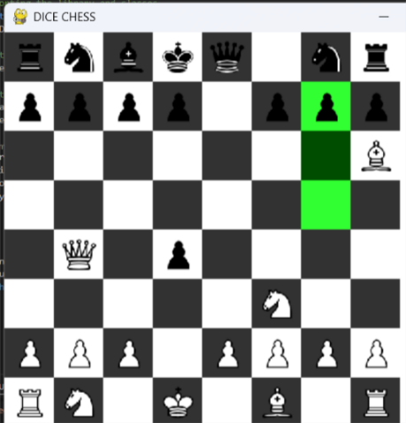
In this position, the black pawn should be able to capture the white bishop diagonal to it, but the square isn’t highlighted.
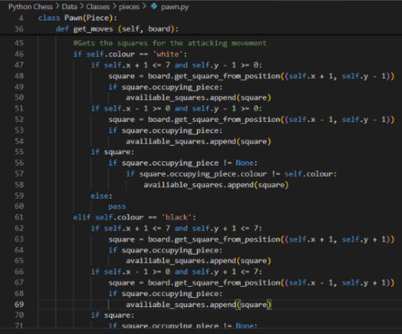
This was an error in the pawn.py class, where I forgot to add the square if there is an occupying piece of a different colour. Because of this, the value of square kept getting replaced, so it couldn’t take both values of the moves. The new version of this prototype allows for the pawn to attack diagonally.
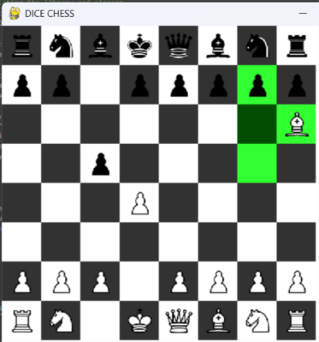
The final thing to make this test a success is to allow for En Passant.
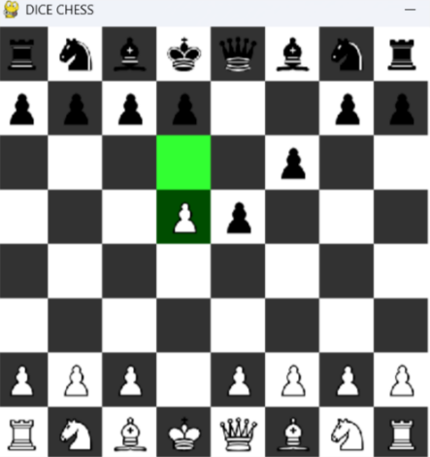
In this position, there should be a highlighted square behind the pawn next to the advanced white pawn. I will have to re-evaluate the way I structured the En Passant movement.
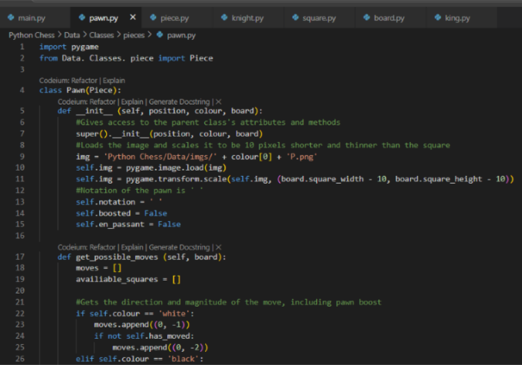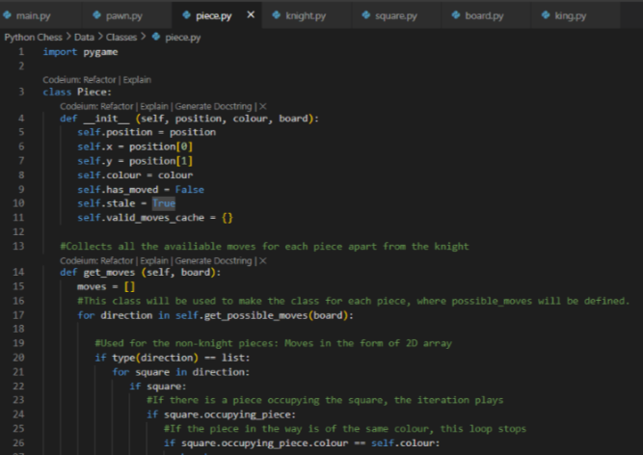
In order for En Passant to be used, the pawn must have both boosted in its previous turn and that must have been its previous move. To ensure this, I added a boosted attribute to the pawns to tell if the previous move was a boost and a stale attribute to all pieces to tell whether they were the last piece to have moved.
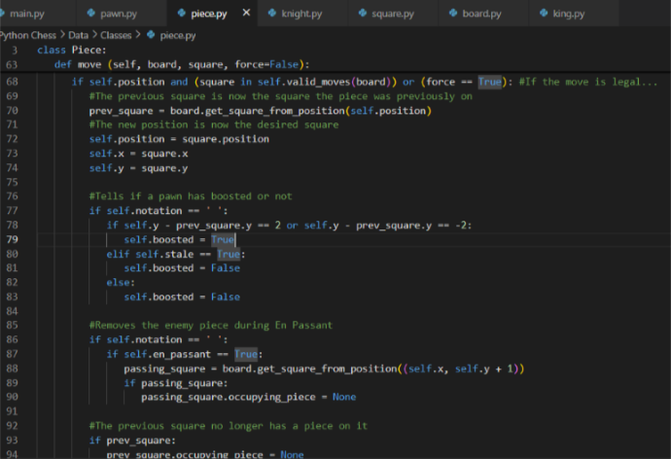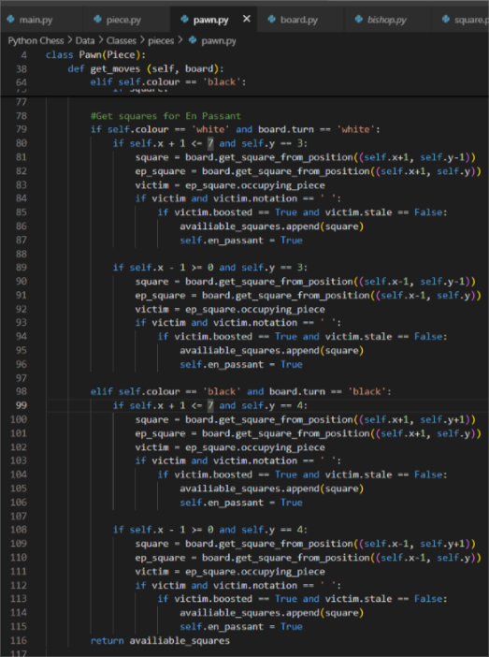
I then implemented these values in my code to produce a prototype that would allow En Passant:

VIDEO 2
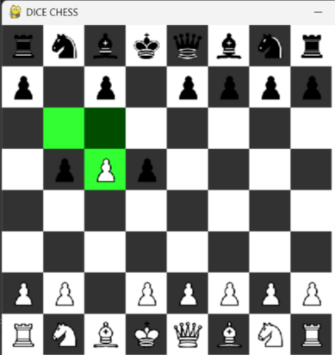
In this example, the pawn on the left just did a pawn boost, whereas the pawn on the right did it two moves ago, meaning En Passant is no longer available.
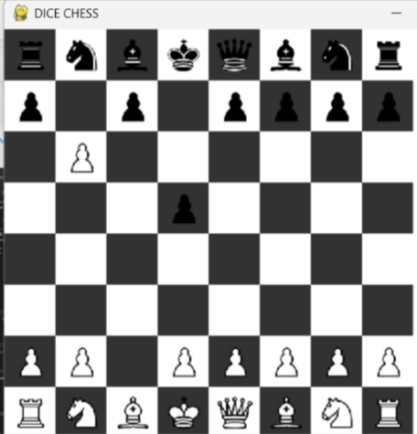
The result of this is a diagonal capture as if that pawn only moved 1 square forward.
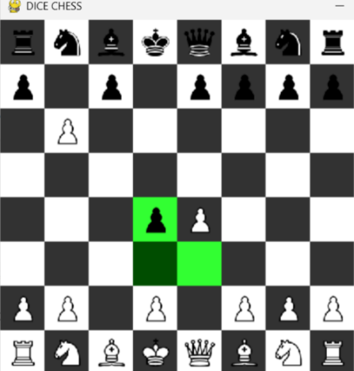
A similar situation is true for the black pawns.
This concludes a success for Test #3.
Before moving on, it is important to note that the previous designs for the board were inaccurate. The colours of the squares should be flipped, and the king and queen must swap places. Based on this, the new model for the board can be seen below:
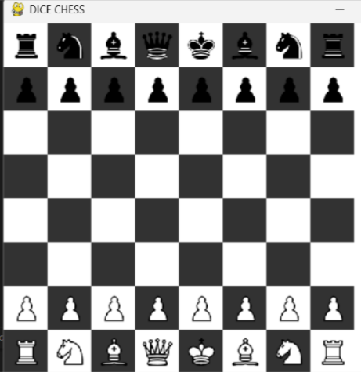
Unfortunately, Test #4 was not successful as the moves for castling do not appear highlighted and cannot be made:
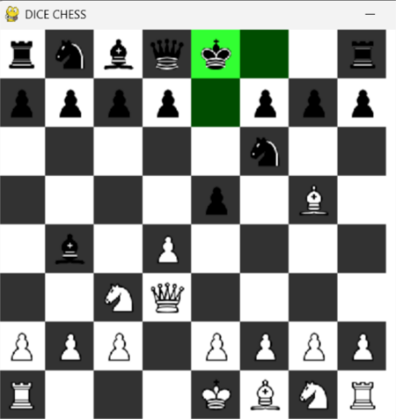
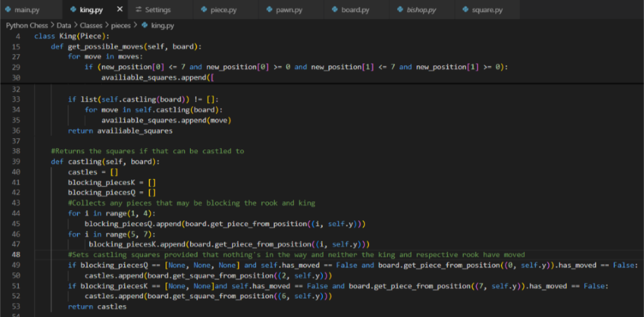
To fix this, I made a method castling that creates a list of squares that the king can castle to, provided the conditions are met. This allows the king to move their castling square. The rook will also move automatically due to one of the methods in the Pieces class. The result is as follows:

VIDEO 3
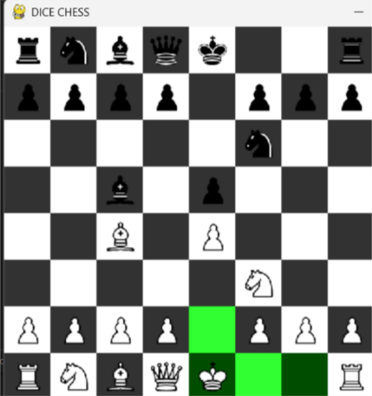
This also works for black as well as the other direction:
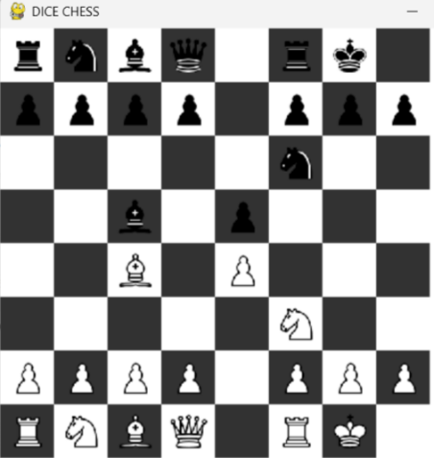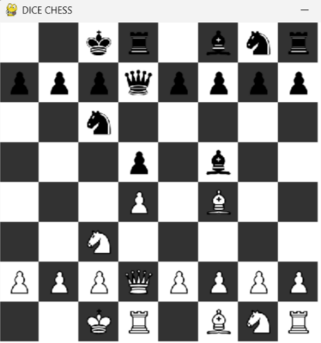
This leaves Test #4 a success.
Tests #5 and #6 have been easily met with favourable outcomes, as shown during previous tests. In the previous screenshots, we can see that pieces can only move in their respective patterns, satisfying Test #5, and that our own pieces cannot be captured, satisfying Test #6.
The same cannot be said with Test #7.
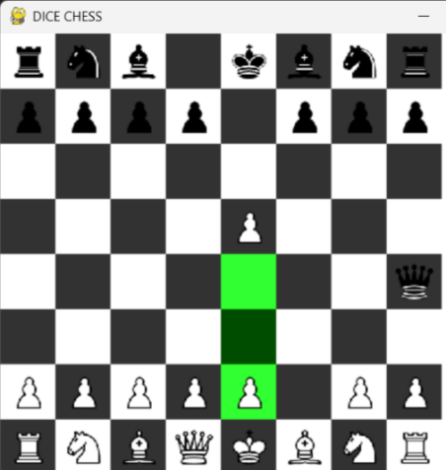
In this position, the only moves that should be allowed are those that block the queen from capturing the king. However, this is not the case as the pawn in front of the king can move forward, leaving the king vulnerable.
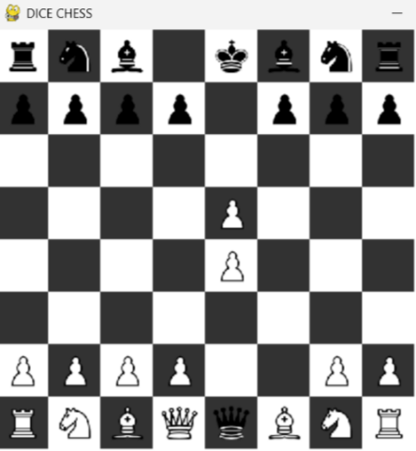
This unfortunately results in the king being captured, which would be allowed in Dice Chess or Dice Chess Xtreme, but not in the regular version.
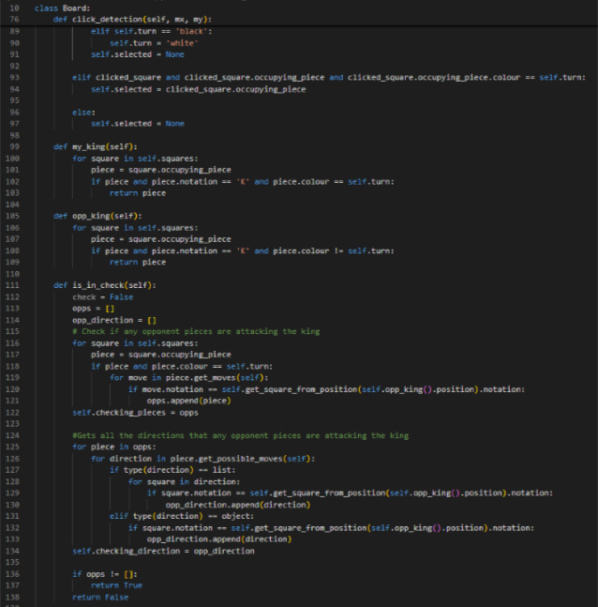
For this, I had to add three new methods to the Board class:
my_king, opp_king and is_in_check. The first two return the friendly and opposing kings respectively as objects. The last one returns if a player is in check or not.
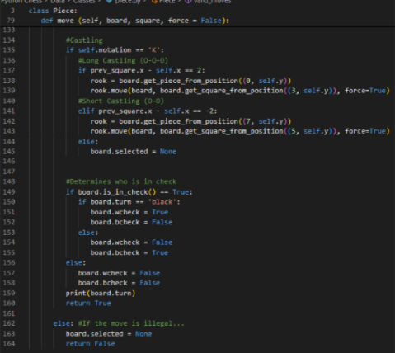
To determine who was in check, I added the attributes wcheck and bcheck, which will be true is white or black are in check respectively and vice versa. Both attributes cannot be true at the same time. I set this in the move method in the Piece class since a check should be determined after a move is made.

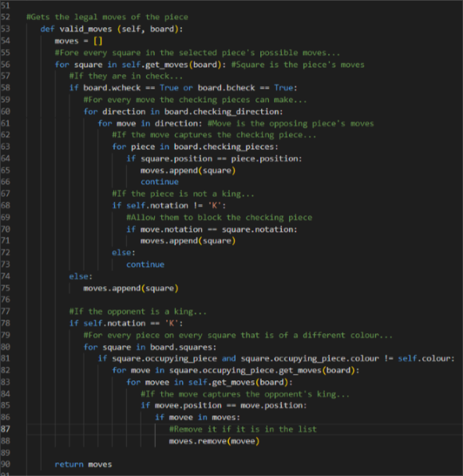
To implement the check conditions in my code, I added it to the valid_moves method, which filters the move is a player is in check. If they are, it only allows moves that block the checking piece, capture the checking piece or move the king out of the way. It also prevents the king from moving into a new check, regardless of whether it is currently in check.
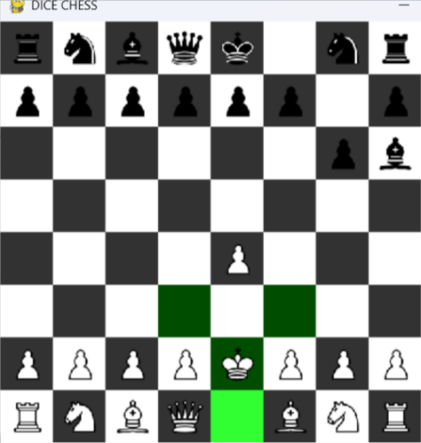
When retrying Test #7, the king is incapable of moving diagonal to the bishop on the edge. This prevents a king capture, which follows the rules of chess.
We also need to account for potential pins:
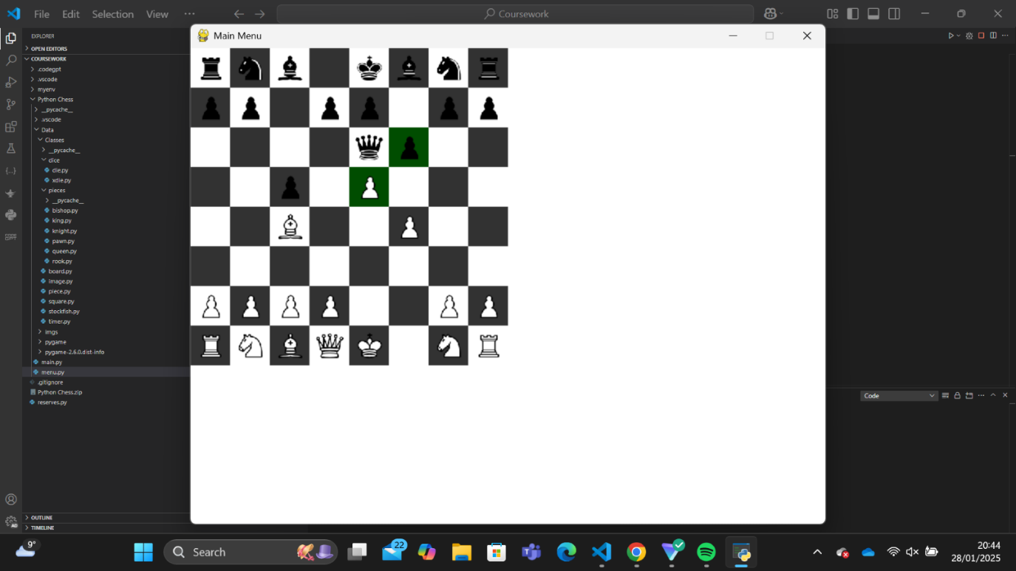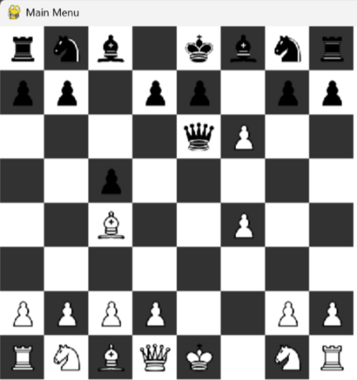
In this situation, the pawn can legally move out of line with the queen, exposing the king to being captured, going against the rules of chess. While an improbable move, the rules of chess would not allow this.
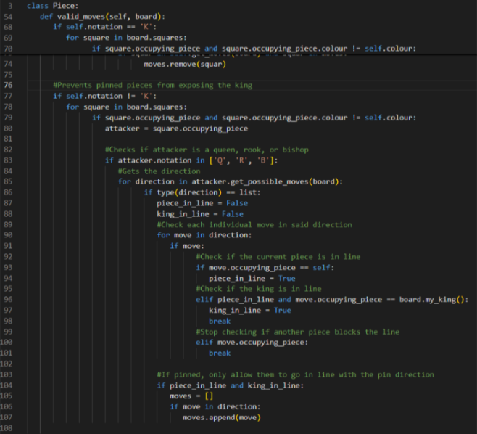
To solve this, I added some code the valid_moves method. This checks all enemy rooks, bishops and queens to see if the piece and its king line up for a pin, with no other pieces between the piece and attacker or piece and king. If the piece and king line up without any blocking pieces, the piece’s move set will be limited to that direction.
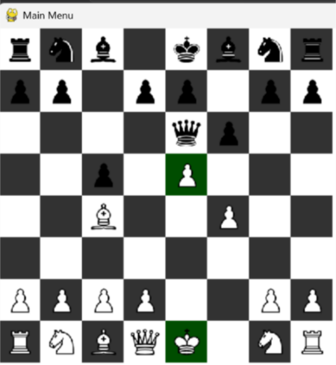
This change prevents the pawn from moving after the same sequence of moves, even highlighting the king’s square to indicate the reason why the piece cannot move.
This improvement leaves Test #7 a success.
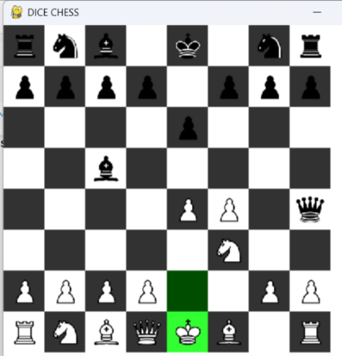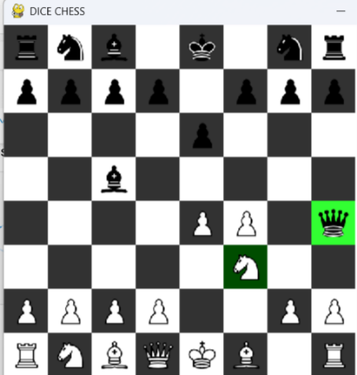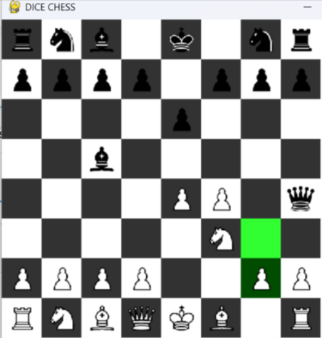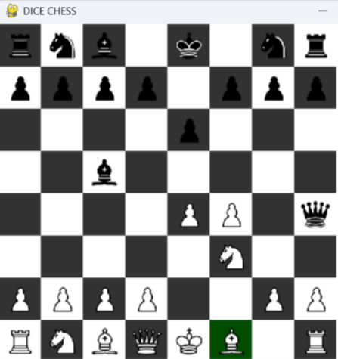
A similar success for Test #8 follows as a result of the success of Test #7. In the first screenshot, the king’s only move is to move out of the way of the check. It cannot move in line with the queen or bishop as that will keep him in check.
The second screenshot shows that the knight can capture the queen that is checking the king, while also preventing every other knight move, as they will keep the king in check.
The third screenshot shows that the pawn can block the queen that is checking the king, while also preventing the other pawn move, as they will keep the king in check.
The fourth screenshot is an example that shows that pieces that cannot help with getting out of check cannot move from their position, as their movement could result in the king being captured.

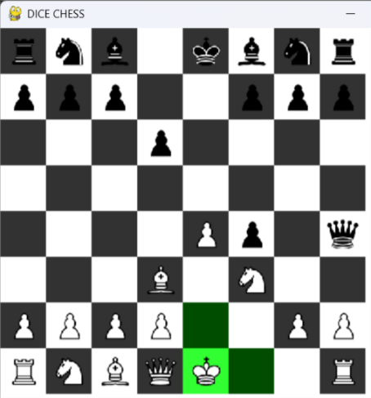
Test #9 was also a success. The queen on the end has put the king in check. Under normal circumstances, the king would be able to castle to safety, but since it is in check, castling is not available. The queen must be dealt with (without moving the king or rook) in order to castle.

For Test #10 we need to consider the additional conditions that prevent castling:
- There are pieces between the king and rook
- The king has moved
- The castling rook as moved
- The king would pass over or end up on a square that would put him in check if he moved to it
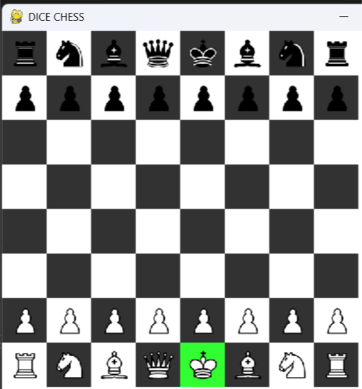
This screen shot shows that with the full set of pieces between the king and rooks the king will not be able to castle.
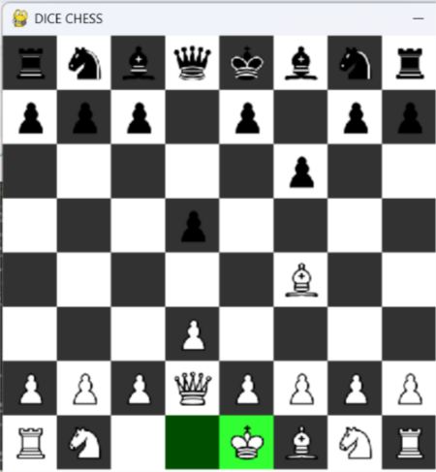
Even if just one piece is blocking, the king and rook cannot castle. Even though neither the king nor rook will end up on the knight’s square, they need to have no pieces between them to castle.

VIDEO 4
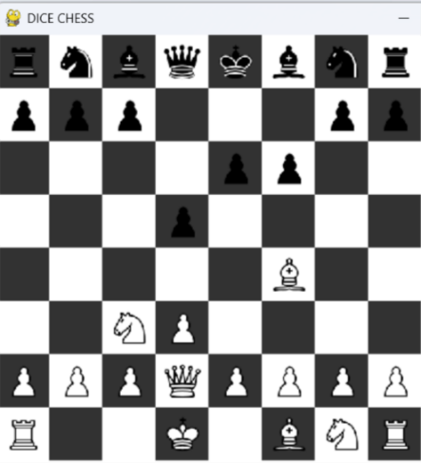
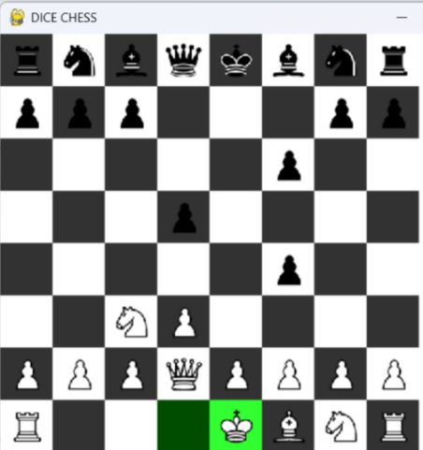

The next pair of screenshots shows the king moving, then going back to its original square in order to castle. However, since it has moved already, castling is no longer an option, satisfying the second condition.

VIDEO 5
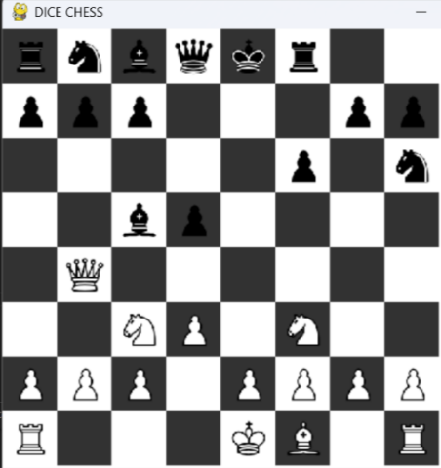
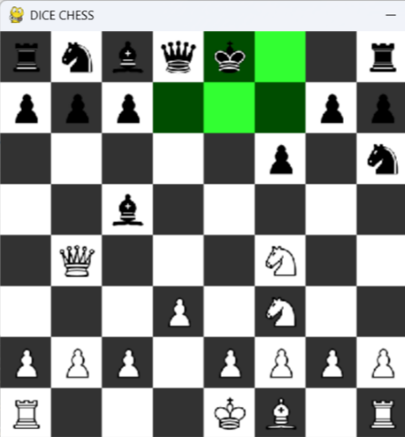

Similarly, when the rook moves, castling is also no longer available, as per the third condition.
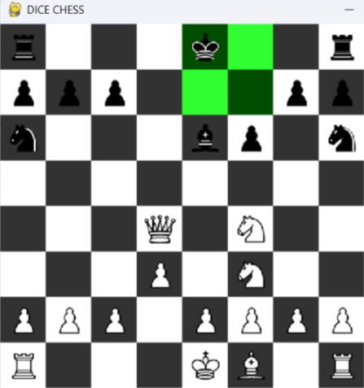
For the final condition, we can see that when the queen attacks a square that the king would move over, castling is not an option, satisfying condition 4.
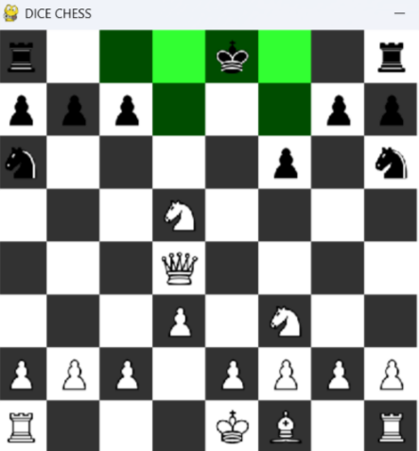
When that restriction is released, the king can castle again.
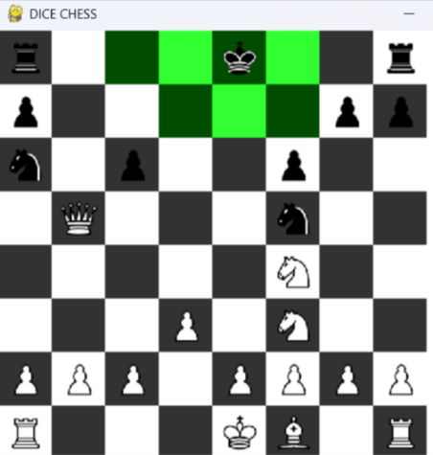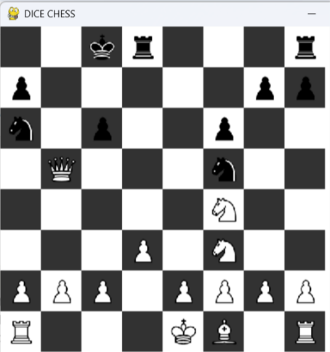
One final thing about this test is that the rook does not share condition 4 with the king. This means for queenside castles, even if a piece attacks the square next to the rook, castling is still allowed.
This concludes Test #10 as a success.
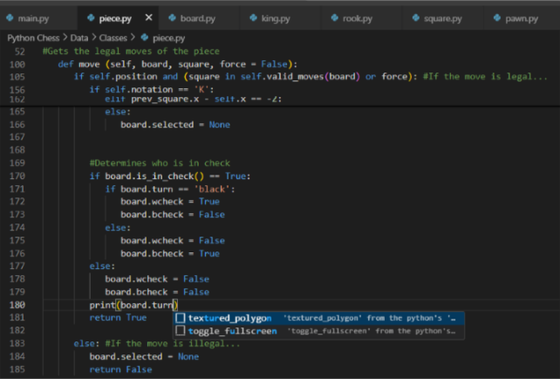
For Test #11, I decided to print whose turn it is after every move is made.

VIDEO 6
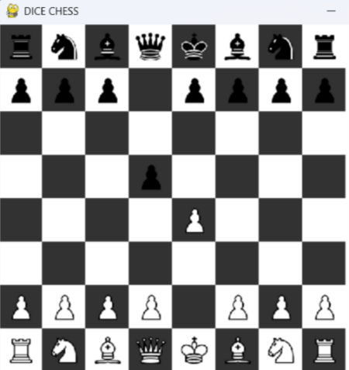
In this test, I had white make a move, followed by a black move. This result shows that it was white’s turn the instant before their move was made and a similar result for black. This leaves Test #11 a success.
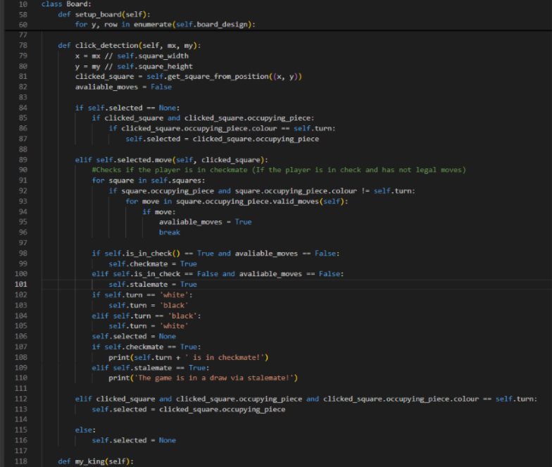
The adjustments to the Board class check if the opponent is in checkmate or stalemate when a player makes a move by checking if they have any legal moves. If they don’t are in check, they are in checkmate and lose the game. If they don’t but is not in check, they are in stalemate and draw.
The following games will show examples of when white is in checkmate, black is in checkmate and when a draw occurs. The expected outputs should go as follows:
- ‘white is in checkmate!’
- ‘black is in checkmate!’
- ‘The game is a draw via stalemate’

VIDEO 7, VIDEO 8, VIDEO 9
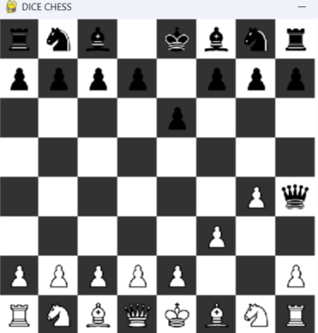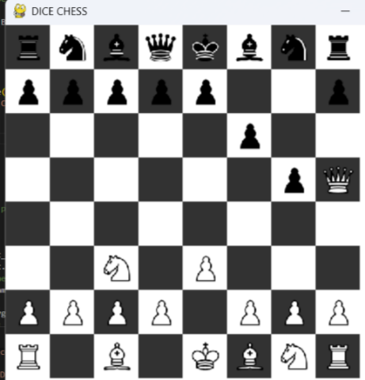
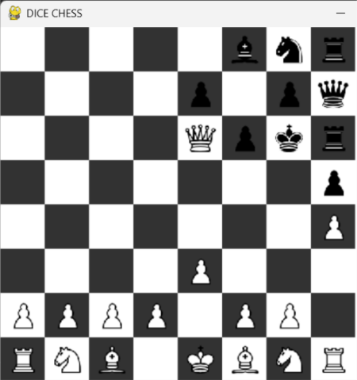
Based on the screenshots above, tests #12 and #15 are successful. Tests #13 and #14 will be completed later as this becomes a two-player game.
For test #16, a new list will be required to store the individual positions of each game.
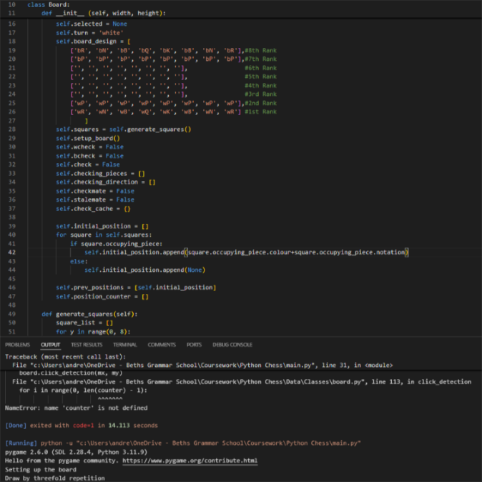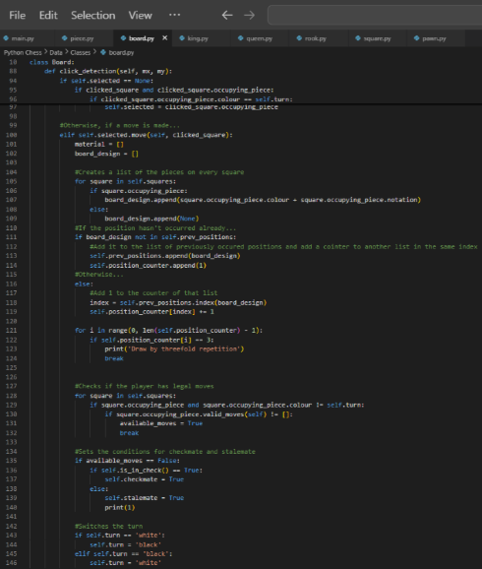
For this, I added three new attributes to the Board class: initial_position, which stores the starting position, prev_positions, which stores every position that has occurred in the game in a list, and position_counter, which stores how many times those positions have occurred in the game in the same index. When a position occurs multiple times, the counter gets updated incremented by 1. When it reaches 3, the game declares a draw by threefold repetition.
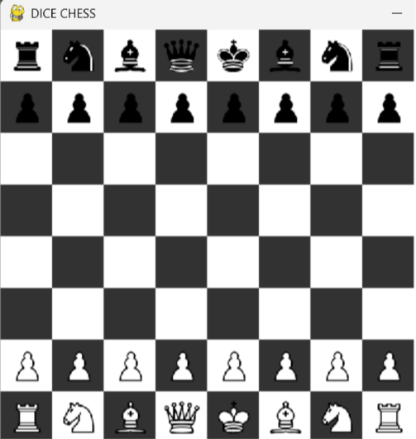
The output after moving the knights back into their original position twice (repeated 3 time if you count the setup) prints the expected outcome, declaring a draw by threefold repetition. This concludes Test #16 a success.
Test #17 will be revisited once the timer and 2-player capabilities have been added.
Test #18 will require me to check the material of the board each move, showing a situation for each of the 5 scenarios that would lead to insufficient material:
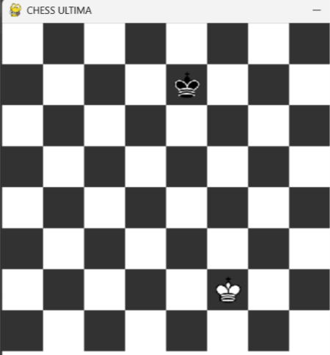
The screenshot above shows that the program does in fact recognise and output that there is insufficient material when there are only 2 kings.

Prototype 3 – Timer:
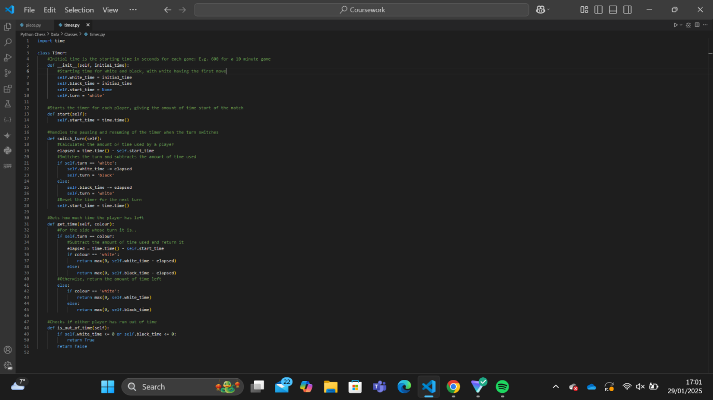
For the third prototype, I will add a timer to the original code. This will allow for tests requiring timers starting, stopping and running out. I will do this using a Time class.

The Time class imports the time library to measure the seconds each player has spent on a turn. The methods in this class determine how long a player has spent on a move, how long they have left, whether they’re out of time and even handle turn switching.

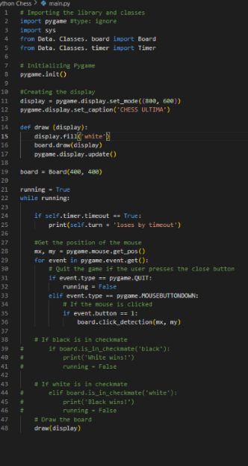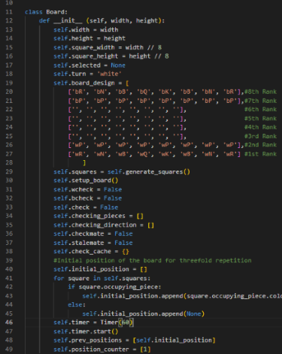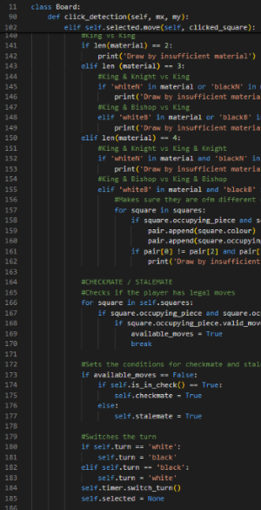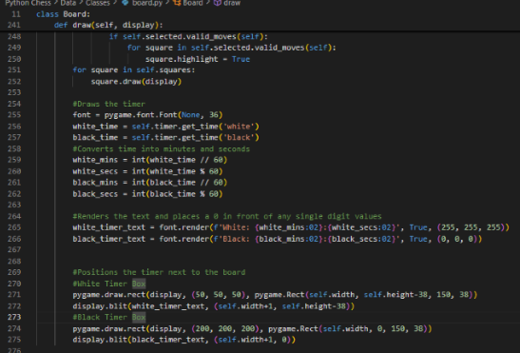
The next part of this prototype consists of 4 parts:
- I imported the Timer class into main.py where it outputs that player lost by timeout when their timer finishes.
- I imported the class into board.py and set attributes to the Board class that would start the timer. It is initially set as 60s.
- In the click_detection method, I switched the turn in the Timer class whenever a move is made
- In the draw method I drew some timer boxes then put the text that would show the time inside them. The format of the time must be adjusted to output minutes and seconds instead of just seconds (1:00 rather than 60)
This not only draws the timer next to the board, but it also says when the time is up and who loses when that happens.

VIDEO 15
The video shows that the timer can successfully pause and start times based on who made the previous move. It can also show the timers in with the correct format and an appropriate place on the screen. However, it shows that it will not output the correct timeout message when a player runs out of time.
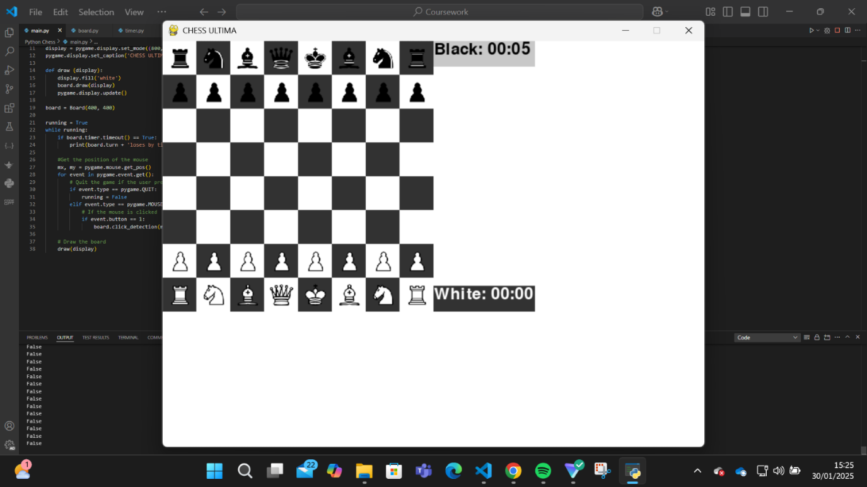To find the problem, I had the program output whether a player has run out of time. After 00:00 appeared on the white counter, I expected the last few printed strings to be ’True’. However, they happened to be false throughout. This means that the timeout method never returned True when time ran out.

VIDEO 16
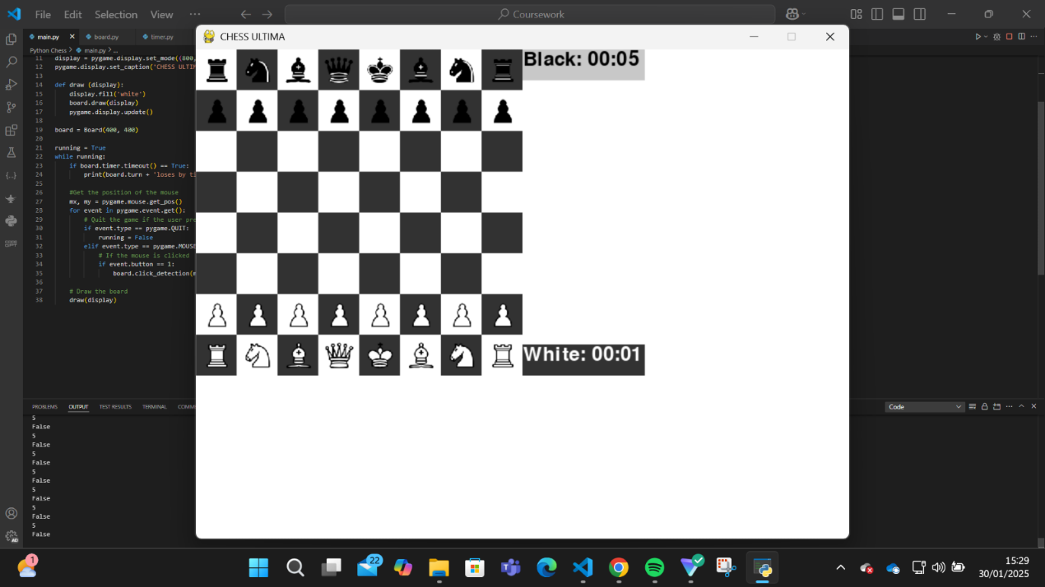I then had it repeat the white_time attribute. This revealed that the white_time and black_time attributes hold the initial times without changing throughout the course of the game.
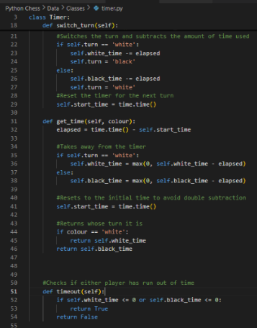
To solve this, I adjusted the get_timer() method. Instead of returning the amount of time remaining, it adjusts the white_time and black_time attributes accordingly. This ensures that they countdown as required. Since the timeout method only checks these attributes, thise are the ones that need changing.
*Insert video of code printing ‘white loses by timeout’ after white runs out of time.
As seen from the video, the program is now able to determine whether someone loses from running out of time.
The final part of this prototype is to make sure that the game ends in a draw if one player runs out of time and the other player runs out of material.
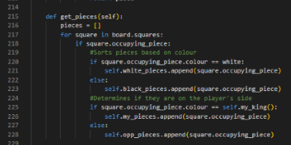To simplify the task, I decided to create a method get_pieces, as well as introduced 4 new attributes to the Board class: white_pieces, black_pieces, my_pieces, and opp_pieces. These sort pieces based on colour for the former pair and relation to the player for the latter pair. These attributes will be able to replace huge chunks of code that require me to gather a group of pieces based on their colour or whether they are allied to the player.

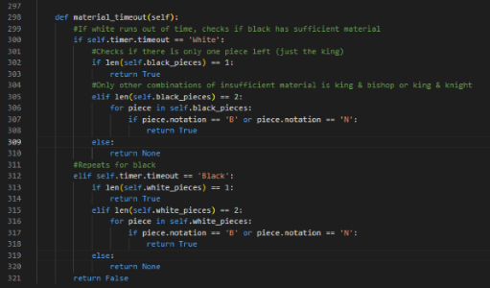
To complete this part of the solution, I created a new method material_timeout. When the timer runs out for one side, it checks if the other side has sufficient material to checkmate the other player. If they don‘t, it outputs that it is a draw due to insufficient material and timeout. Otherwise, it outputs that the player who ran out of time lost via insufficient material.

VIDEO 17

Prototype 4 – Dice:
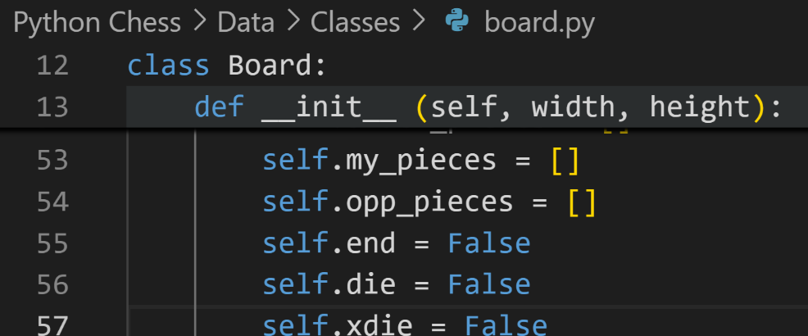
To implement the dice, I added the die and xdie attributes to the Board class. These determine whether the die, xdie or neither are supposed to be used. These will determine whether there should be a dice animation and whether there should be a restriction of moves.

Prototype 5 – Main Menu:
This prototype will work on the main menu of the game. This will give options for players to go to different areas of the program.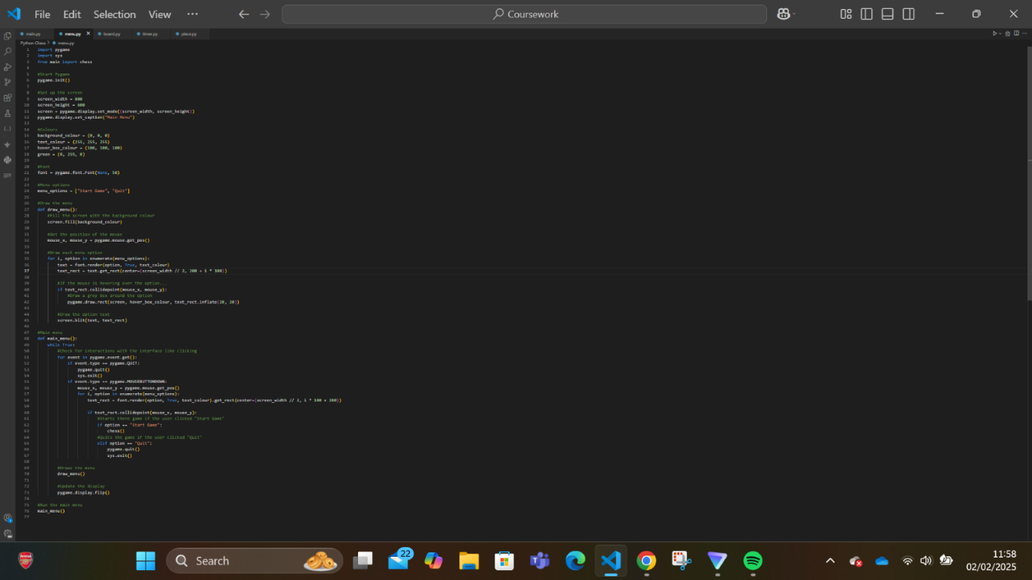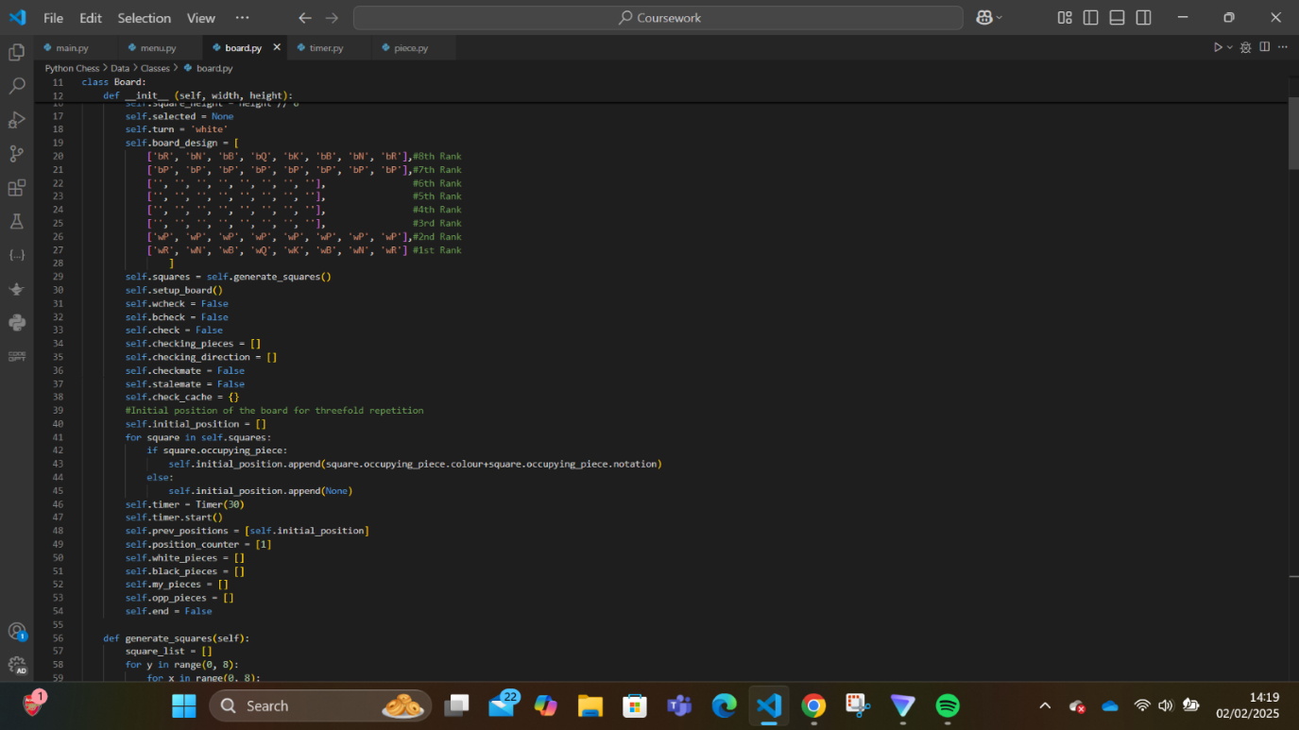
To create the main menu, I made a file called menu.py which contains the code that will generate the menu and handle the options. Currently it has 2 options:” Start Game” and ”Quit”. When the mouse hovers over these buttons, a grey box appears around the text to show which button the player would be clicking on.
To ensure that the game would play when a player decides to start the game, I put the ‘while running’ loop as a function. This would allow me to execute it in another file. I would also allow me to stop it running when a player loses or draws the game.
I also added an attribute end to the Board class. This would become True in conditions that would cause the game to end, such as checkmate. This will stop the game automatically when true.
*Insert video 3
This video shows that the main menu can allow the user to either start the game or quit the program. This shows that the main menu is effective in allow the user to start a game whenever they want rather than being thrown into a game upon starting the program.

Full Code:

Main.py

Square.py

Board.py

Piece.py

Pawn.py

Knight.py

Bishop.py

Rook.py

Queen.py

King.py

Timer.py

Menu.py

Evaluation
When identifying how well each success criterion and usability feature was met, the notation will consist of the following:
F – Fully Met
P – Partially Met
U- Unmet

Post-Development Survey Answers pg 36:
Qu Nº | Henry’s answer | Michael’s answer | Efe’s answer | Overall feedback
1 | “No, no I can’t. There’s no online feature.” | “I can play with people, but I cannot play online” | “If I had a friend at the computer with me, I could play with them, but I cannot play online” | Whilst the players can play with each other on the same device, they cannot play with other players on separate devices online.
2 | “I cannot make a single illegal move.” | “No, the game prevents illegal moves from even being an option” | “I try to make illegal moves to win, but the program won’t let me” | Players are able to make the correct moves in the correct circumstances. They cannot make illegal moves, following the rules of chess. The movement patterns match that of the real game.
3 | “There’s no engine.” | “There isn’t a chess engine to review my game, but Stockfish is free, so that’s not really necessary I can use.” | “There isn’t an engine in the program, but I can find one online, so it’s fine.” | The players cannot analyse their moves with my program since there isn’t a ches engine available. However, this is one of the less important features since players have other sites for engines.
4 | “There isn’t a login feature.” | “When opening the program, it doesn’t take you to a login screen so I can’t make an account.” | “I cannot create any account, so there’s not much to say.” | There is not a login feature, meaning that players cannot create their own account to save their data and make it their own.
5 | “I can easily access the game and from the menu.” | “It is very hard to get lost in this program. It is very easy to understand the menu.” | “I like the minimalist menu. It is really simple to start playing as soon as you open it.” | The program is very easy to navigate. However, this make be because of the lack of features rather than good programming.
6 | “The board is pretty accurate to regular chess.” | “The board and pieces fit well, matching that of my chessboard. That is the best feature of the game.” | “The board is well structured, and the pieces fit well into them. They are arranged nicely at the start.”
7 | “Chess is difficult to play, but moving and capturing pieces is very easy in this program” | “The game is very simple to play. Someone who is accustomed to other sites can very easily start playing this game.” | “The controls are very similar to Chess.com so I didn’t have a problem with playing the game”
8 | 5 | 6 | 5
9 | “The program could be improved by adding some more features like a login. It would also be cool to be able to play with someone on here.” | “Some of the features weren’t there. I would have liked for my variation of the game to be present.” | “The program is ok for an offline version or to show someone what chess is. I probably won’t use it to actually play the game though.”

Success Criteria pg 20:
Criterion Number | Status | Explanation | Test Evidence | Improvement Feedback
1 | U | There is indeed a main menu, however, due to the incompletion of the project there aren’t a lot of features on the menu. It can only really load a game or quit. | Tests 29-32 | I could add some more features like more variations, additional designs and colour schemes for the game and the ability to turn timers on and off.
2 | U | The program can only apply one of these variations. This doesn’t really give the user a choice on what version they want to play. | Tests 23-26 | I could add modules that would alter the way certain parts of the code run based on what variation the player wanted to play.
3 | F | There is a pretty good model of the chessboard. It has all the pieces in the correct initial position and squares in appropriate colours, both of which are of suitable sizes. | Test 1 | I could add coordinates to help new users visualise the board and think using chess notation.
4 | F | In this project, the way moves are determined is very accurate to the real thing. The illegal moves aren’t even highlighted to suggest they can be complete. This criterion was accomplished well. | Tests 5-10 | I could place the reason why the piece’s movement is restricted in a corner so that players can watch out for the patterns of the game.
5 | F | This criterion was also fully accomplished and compliments the previous one. The players can move in all the ways that are possible in a normal chess game. | Tests 2-4 | The pieces move perfectly like in regular chess, so there isn’t much to improve upon in this criterion.
6 | F | This was fully met as the timers work identically the those in regular chess solutions. | Tests 20-21 | I could create a feature that would allow players to change the design of the timers. I could also allow for variations where the timer increments by a certain amount of time every move.
7 | U | The game didn’t have the feature of storing the moves in any way to be used later. | Tests 2-4 | I could add the ability to store moves and games so they can be analysed in the future.
8 | U | There was no random number generation feature | Tests 23-26 | I could add the random number generator with a die animation.
9 | P | The program was easy to navigate. However, that is only because there isn’t a lot to navigate. It is ambiguous if completing this will change the navigation difficulty, so I cannot say that this was fully met. | Tests 29-32 | Similarly to the first criterion, I could add additional areas of the program to navigate, while trying to make the navigation as simple as possible for the user.

Usability Features pg 26:
Feature | Status | Explanation | Improvement Feedback
1:  Return Button | U | There was no need for a return button since the only options were to either play the game or end the program. If I added more areas to the program, a return button would likely be present. | To improve this, I could add these areas, with a return button to go back to a previous page in case the user accidentally goes to the area.
2:  Colour Scheme | U | Only one colour scheme could be used in my program. The user doesn’t get a choice in whether to change the colour or not | I could add a settings option to the main menu, where the user can toggle between light and dark mode, and maybe even some other colour schemes like blue or green.
3:  Simple Interface | F | The was a very simple interface for the player to interact with. For someone to use this program, the main issue would be their individual chess skill, rather than not being able to use the interface. | This can be improved further with a similar method as the previous one. I could add the ability to change how the game presents itself, perhaps through font of piece design.
4:  Toggle Features | U | Since there was no settings feature, the user couldn’t toggle between the different features of the code. | Similarly to the previous tool, the settings feature could be created to toggle between different themes, designs and gameplay styles
5:  Login Screen | U | There wasn’t a login screen since I didn’t put in online capabilities for this program. | I could use an API to place a login feature into the code to allow players to switch devices while keeping their data.
6:  Tutorial | U | The wasn’t a tutorial feature in the game, so this was an unmet feature. | I could improve this by either creating my own slideshow or taking the user to a tutorial on another site.

Maintenance Issues:
Issue | How it may affect the program | How it can be fixed
Repeated lines of code | These repeated lines of code may affect the overall performance of the program, giving a worse experience for the user. It could also make it harder and more tedious for other programmers to improve upon the program as they will have to change every copy of those lines. This makes the program not as robust as it could. | I could create more subroutines for these lines of code in order to minimise the amount of unnecessary code. This would make fixing and improving the code easier since I would only have to fix the line(s) of code once rather than for every time it is used.
File length | Board.py and Piece.py have 331 and 219 lines of code respectively. This may make it difficult to adjust the classes contained in them since it will be difficult to navigate and find the specific method or attribute that needs adjusting. This may make improvements more complex for both me and developers trying to improve the code. | I could separate them into smaller classes that do distinct functions to make navigating them simpler. For example, I could separate the Piece class into a Legal_Moves class and Moving class. This will make it easier to fix specific problems with each part of the program. In this case, if I wanted to fix what legal moves a player can make, I would look through the shorter Legal_Moves class instead of scrolling through the Piece class.
Method length | Some of my methods are extremely long with many lines. For example, the valid_moves method in piece.py is 76 lines long. In comparison, the whole of the square.py class is only 48 lines.  This would make it more difficult to spot and fix errors with a specific part of the program since I would have to navigate through one method that does a lot of functions. | I could separate some methods into smaller methods to improve robustness. This will allow developers to more easily fix these methods if they want to improve the program.  For example, I can split my valid_moves method into multiple method that filters out the moves: castling method, pin method, check method, etc.
Outputs | In the game, the outputs that determine the end of the game are printed into the console, rather than displayed on the screen. This could confuse the player and would force them to look at the console to understand if and why their game ended. | I could display onto the screen who wins a game or if it were drawn. This would make the player’s experience a lot easier as they could immediately determine the outcome of a game and the reason behind it.

Conclusion:
Based on the comparison with the design and feedback from stakeholders, this project can be considered a partial success. Whilst it is still incomplete and lacks most of the features that my stakeholders wanted, they could probably still find some use for it. It still has the features of regular chess it is easy to use. It doesn’t compare to other chess sites like Chess.com and Lichess, but it can be used if somebody wanted to play this specific variation of chess with their friend. All in all, while there are still some features that need to be added, it can still allow the user to play chess, which would still help with the ultimate goal of this project, to make chess more accessible to everyone.

